Title: Crisis Recognition
Recommended Time: 1.5-3 hours (depending on inclusion of Optional Learning Activities)
Primary Audience: Patrol Officers
Module Goal: Through classroom instruction and discussion, the student will learn basic skills of how to recognize a person in behavioral crisis. The student will be able to identify key behaviors and learn some basic tips and techniques to begin to defuse critical incidents involving persons in crisis and move toward a safe resolution. (Note that more detailed and specific communication and tactical strategies are covered in Modules 4 and 5.)
Required Materials: Digital presentation (Power Point and video); lesson plan
Learning Objectives: At the completion of this course, students will be able to:
  - Successfully identify behaviors associated with a person experiencing behavioral crisis.
  - Successfully recognize clues that indicate the difference between criminal behavior and the behavior of someone experiencing a behavioral crisis.
  - Successfully recognize the signs of someone attempting to commit suicide-by-cop.
  - Describe and recognize the value of the emotional–rational thinking scale.

Notes: For officers who have completed Crisis Intervention Team (CIT) or similar in-depth training, the material in this module will be familiar and quite basic. However, those officers should be encouraged to actively participate in this module, as the skills covered in CIT training still need to be reinforced. As appropriate, instructors should call upon CIT-trained students to help discuss and amplify key lessons in the module.

Agencies might consider co-teaching this module with 1) local mental health professionals who have worked closely with the police and/or 2) experienced officers who have used their crisis intervention training and skills to successfully defuse and resolve critical incidents involving persons in behavioral crisis.
Recommended Time Allocation
 | Unit | Recommended Time  (minutes)
1 | Learning Activity–1 (Assessment) | 20
2 | Recognizing Someone in Crisis | 30
3 | Learning Activity – 2 (Optional Video Case Study) | 30*
4 | Learning Activity – 3 (Video Case Study) | 20
5 | Suicide-by-Cop | 20
6 | Recap and Discussion | 10
7 | Learning Activity–4 (Community Mental Health Engagement – optional) | 60*
Total |  | 100-190*

* Overall time estimates are dependent upon the inclusion of the optional Learning Activities.

Table of Contents

- Learning Activity–1 (Assessment) 4
- Recognizing Someone in Crisis 5
- Learning Activity - 2 (Optional Video Case Study) 7
- Learning Activity - 3 (Video Case Study) 15
- Suicide-by-Cop 16
- Recap and Discussion 18
- Optional Learning Activity–4 (Community Mental Health Engagement) 19

Overview: Incidents involving persons in behavioral crisis present a unique and difficult challenge for the police, and these types of calls appear to be growing. How these cases are handled can have significant short- and long-term consequences not only on the individuals and their loved ones, but also on officers, their agencies, and their relationship with the community. In recent years, through programs such as Crisis Intervention Team (CIT) training, police agencies have recognized the importance of these situations and have provided specialized training to many police officers.

This module is not intended to replace the specialized instruction provided through CIT or other programs. Rather, this module is intended as a general overview of crisis recognition, which can be augmented by more specialized training such as CIT. This module is specifically designed to help the initial patrol officers arriving to a scene recognize whether a person is experiencing a behavioral crisis. The module pays special attention to possible suicide-by-cop encounters. Often, situations involving persons in crisis are best addressed with the assistance of CIT-trained officers, other specialized police personnel, and even other agencies, once they arrive on scene. Still, the initial responding officers require the tools and skills needed to recognize when someone is in crisis in order to stabilize and manage the situation until those additional resources arrive.

While this module is not “CIT training,” it does touch on a number of issues related to mental illness. To the extent possible, agencies should try to include specially trained subject matter experts, from within or outside the department, in the customization and delivery of this training.

- Learning Activity–1 (Assessment)
Instructor Notes
SLIDE #1
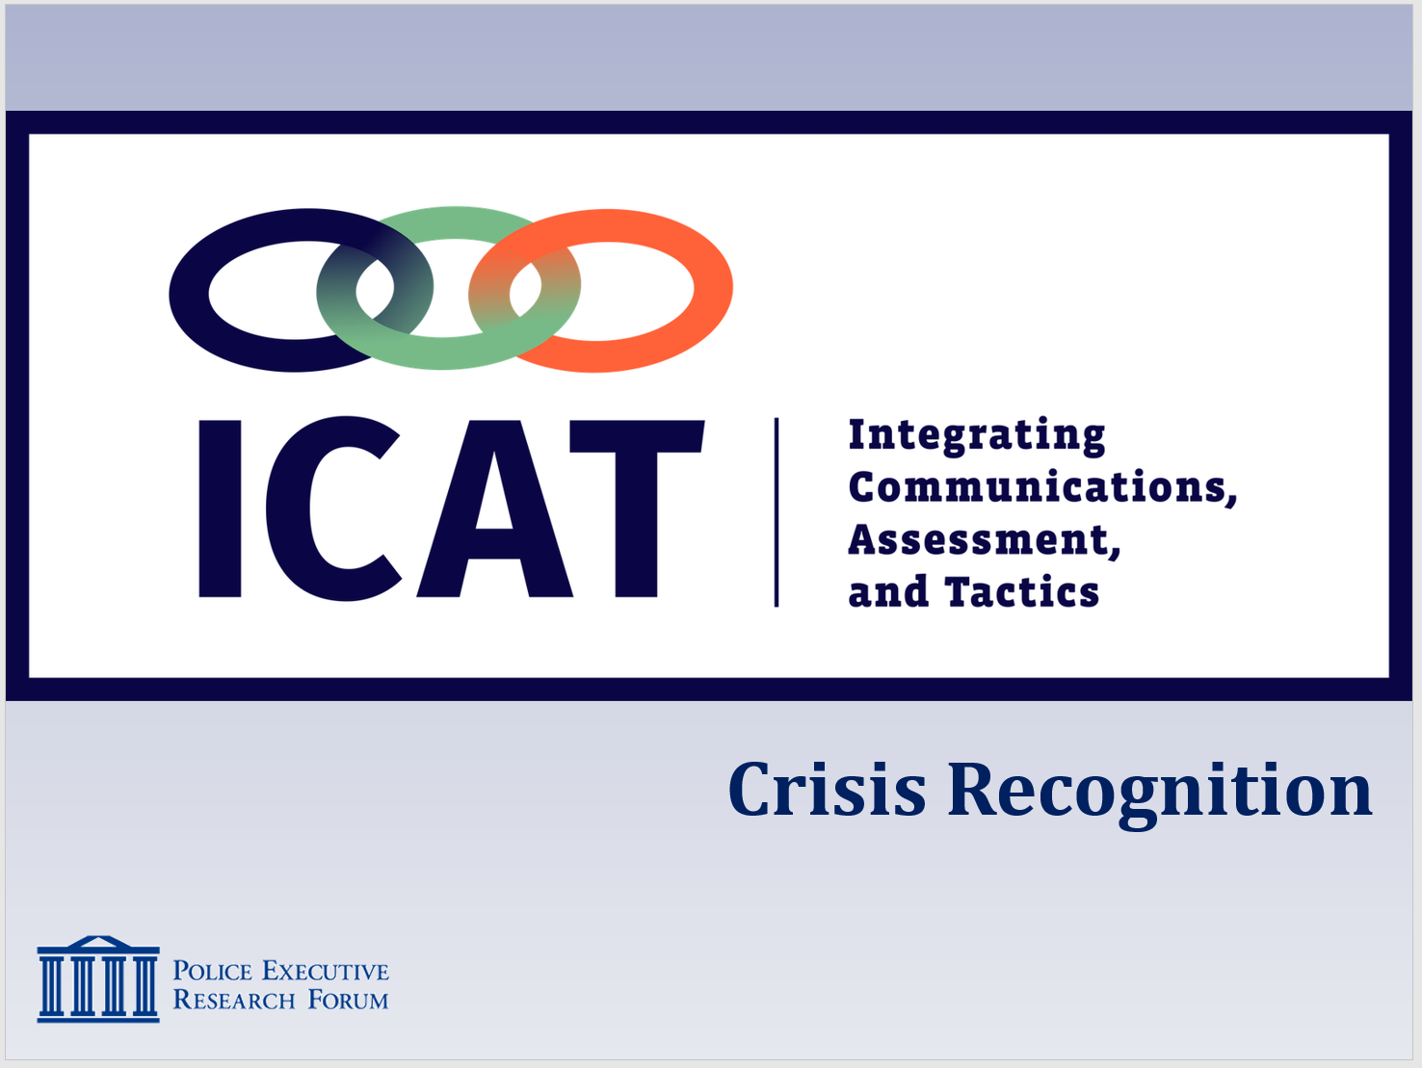

SLIDE #2
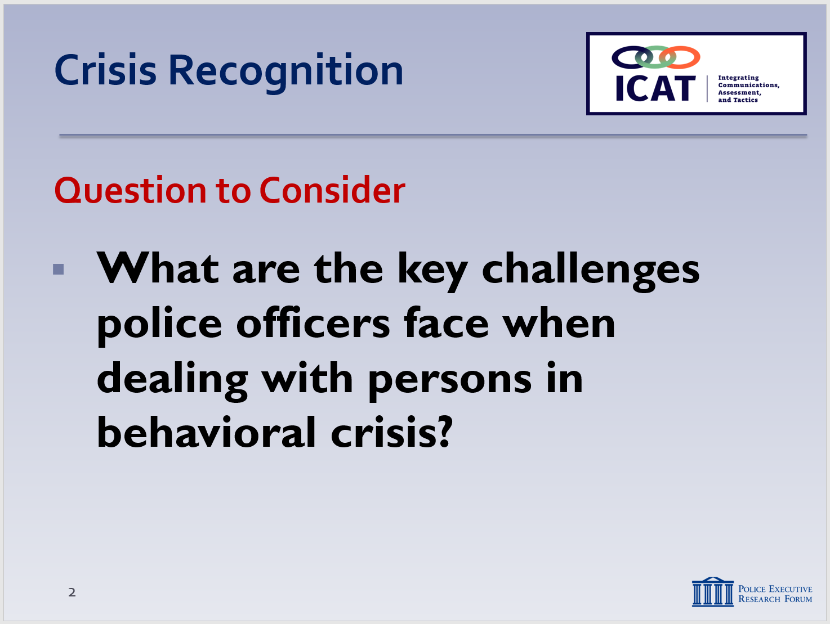
Activity: Assessment Group Project
Activity Time: 20 minutes
Activity Learning Objective: An assessment exercise that serves as an introduction to the Crisis Recognition module
Required Equipment: Easel pads, markers
Facilitator Instruction: Break the class into small groups. Provide each group with markers and easel pads. Each group will have 10 minutes to brainstorm and chart responses to this question: “What are some of the key challenges police officers typically face when dealing with persons in behavioral crisis?” Each group will delegate a spokesperson who will present the findings to the class.

- Recognizing Someone in Crisis
When someone is in crisis there is often a precipitating event, and the individual is unable to resolve the crisis using normal coping methods. When an individual is in crisis, he or she often experiences heightened emotionality and lowered rational thinking. The person in crisis may begin to experience psycho-physical arousal which in turn may bring about physiological changes. This crisis may be a result of mental illness, substance abuse or personal crises, or a combination of factors.

Recognizing the signs of a person in crisis is a necessary first step to effectively responding to that person. Patrol officers are not expected to be able to clinically diagnose a person in crisis. However, officers are more effective during critical incidents, and can achieve safer outcomes, when they can recognize and identify the common signs that a person they encounter may be in crisis.

  - What is a “behavioral crisis?”
    - An episode of mental and/or emotional distress that is creating instability or danger and is considered disruptive by the community, friends, family or the person him/herself
Instructor Notes

SLIDE #3
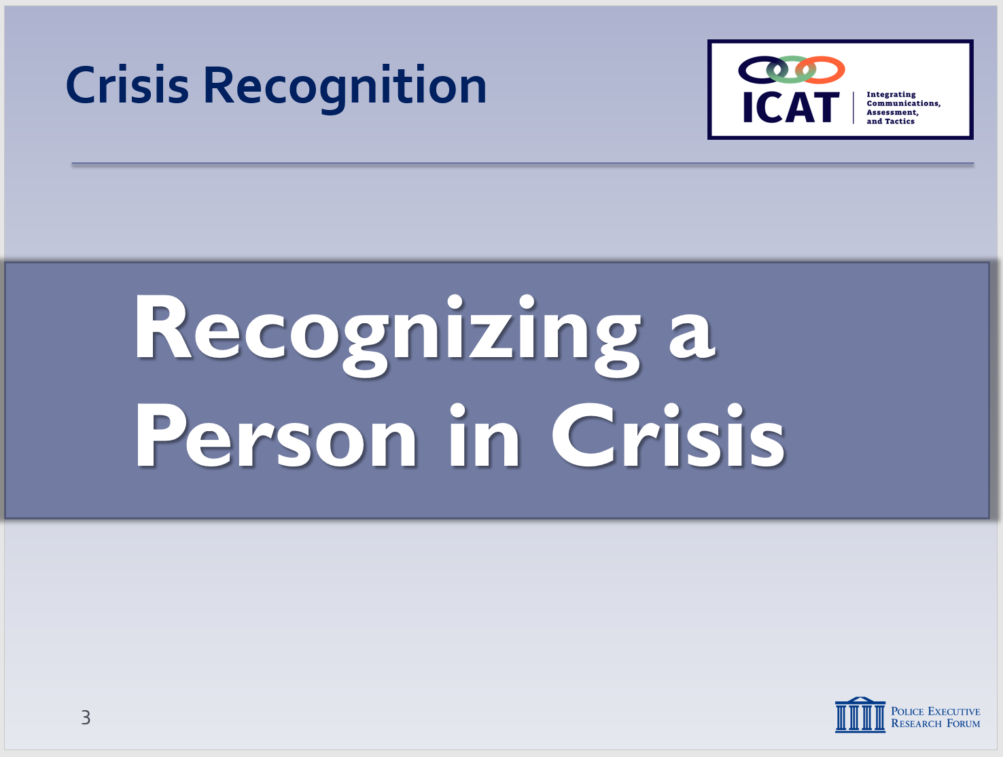

SLIDE #4
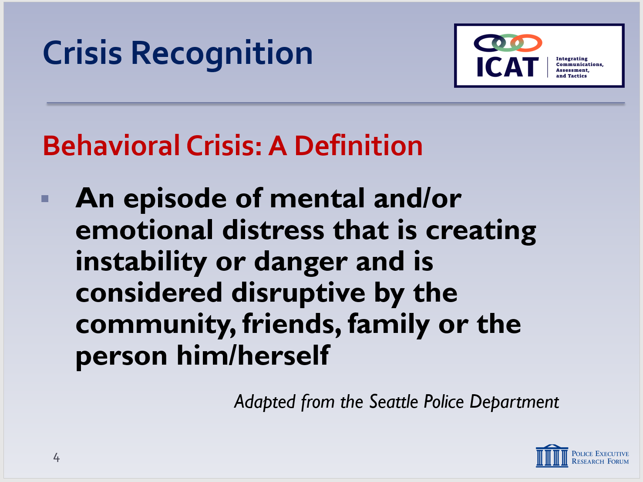
From the Seattle Police Department
Another definition of “crisis”
A real or perceived set of circumstances that makes a person feel that they are unable to appropriately resolve their situation (Police Training Institute, Univ. of Ill.)

SLIDE #5
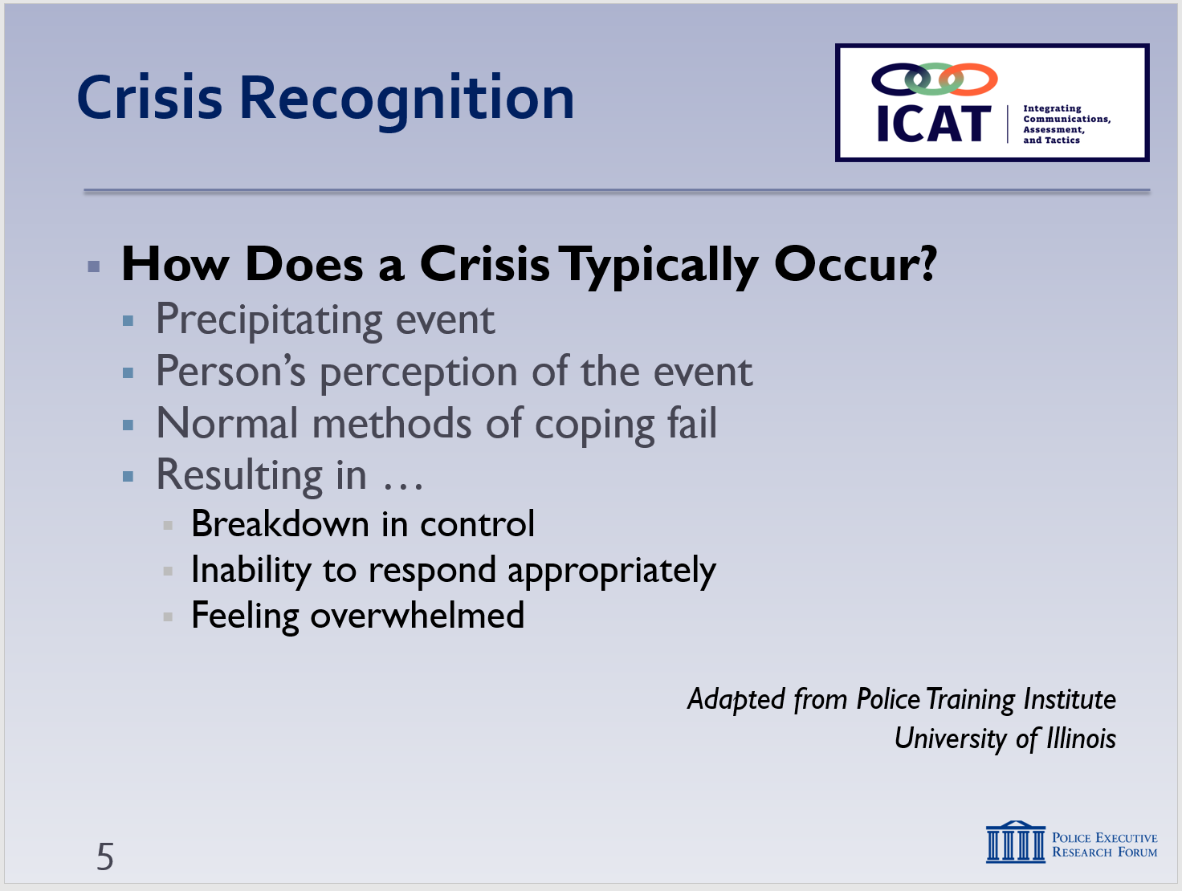
Each crisis is unique. A situation might occur to numerous people but won’t be a crisis for everyone. PERCEPTION SHAPES AN INDIVIDUAL’S REALITY.
    - Three key factors:
      - It’s episodic – a unique event
      - Creates instability or danger
      - Other people (or even the individual in crisis) consider it disruptive – and sometimes dangerous
    - That’s often why people call the police (and not EMS or mental health professionals) when they encounter someone in crisis
    - The police response to a person in behavioral crisis is different, more complicated
  - How does a crisis typically occur?
    - Often a precipitating event (death of a loved one, violence, divorce, job loss, mental illness, reaction to/stopping medication)
    - The person’s perception of the event – which can be accurate, erroneous, or somewhere in between
Instructor Notes

SLIDE #6
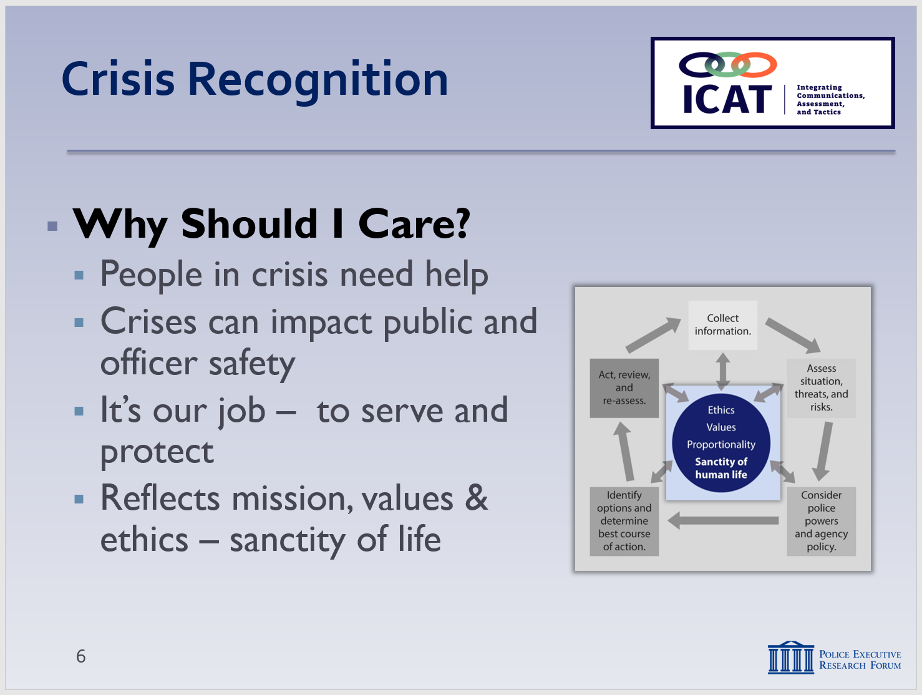

SLIDE #7
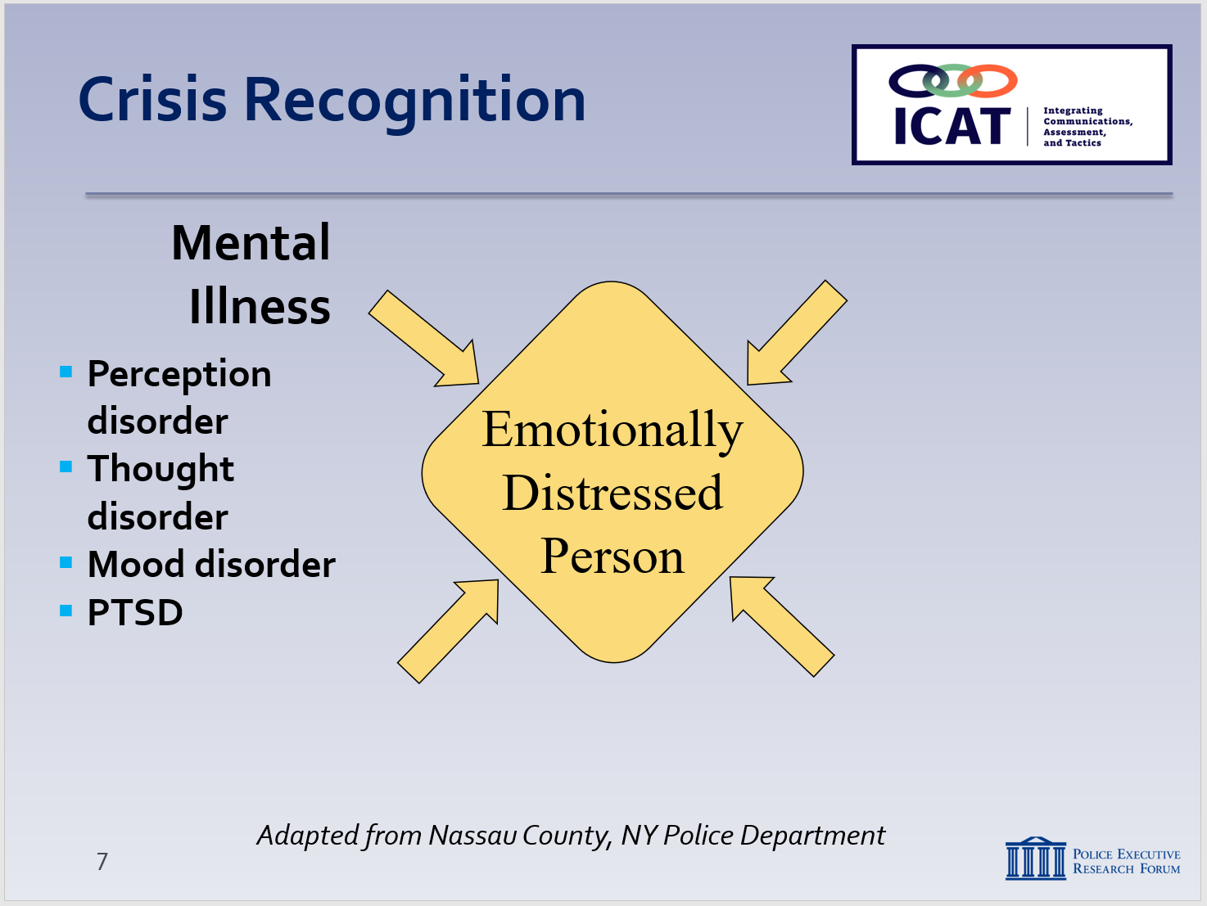
Adapted from the Nassau County, NY Police Department

Some agencies use the term “Emotionally Disturbed Person;” however, the term “Distressed” is preferred
Glossary of terms related to “first episode psychosis”: https://www.nimh.nih.gov/health/topics/schizophrenia/raise/glossary.shtml

For more information on mental health disorders, including video resources please see: http://mentalhealthchannel.tv/episodes

For more on PTSD: https://www.nami.org/Learn-More/Mental-Health-Conditions/Posttraumatic-Stress-Disorder

    - Normal methods of coping/solving problems fail
    - Resulting in …
      - A breakdown in control
      - Inability to respond appropriately
      - Often feeling “overwhelmed”
  - Why should I care?
    - Because people in crisis need help
    - Because crises can impact public and officer safety
    - Because it’s our job – to serve and protect everyone
    - Gets back to the core of the Critical Decision-Making Model – our mission, values and ethics
  - “Person in crisis” sometimes referred to as an
EDP (or Emotionally Distressed Person) –
Four types of possible contributing factors …
    - Mental illness, including …
    - Perception disorder (or hallucinations) – hearing, seeing, touching, smelling or tasting things that are not real
    - Thought disorder (or delusions) – false beliefs that have little or no basis in reality
    - Mood disorder – emotional extremes, violent swings, flatness
    - PTSD – flashbacks, frightening thoughts/dreams, hyper arousal, avoidance, disassociation (out-of-body experiences)
      - May try to cope through drinking, drug abuse
      - Can be significant issue in military communities

- Learning Activity – Tim Wynn Video (Optional)
Instructor Notes

SLIDE #8
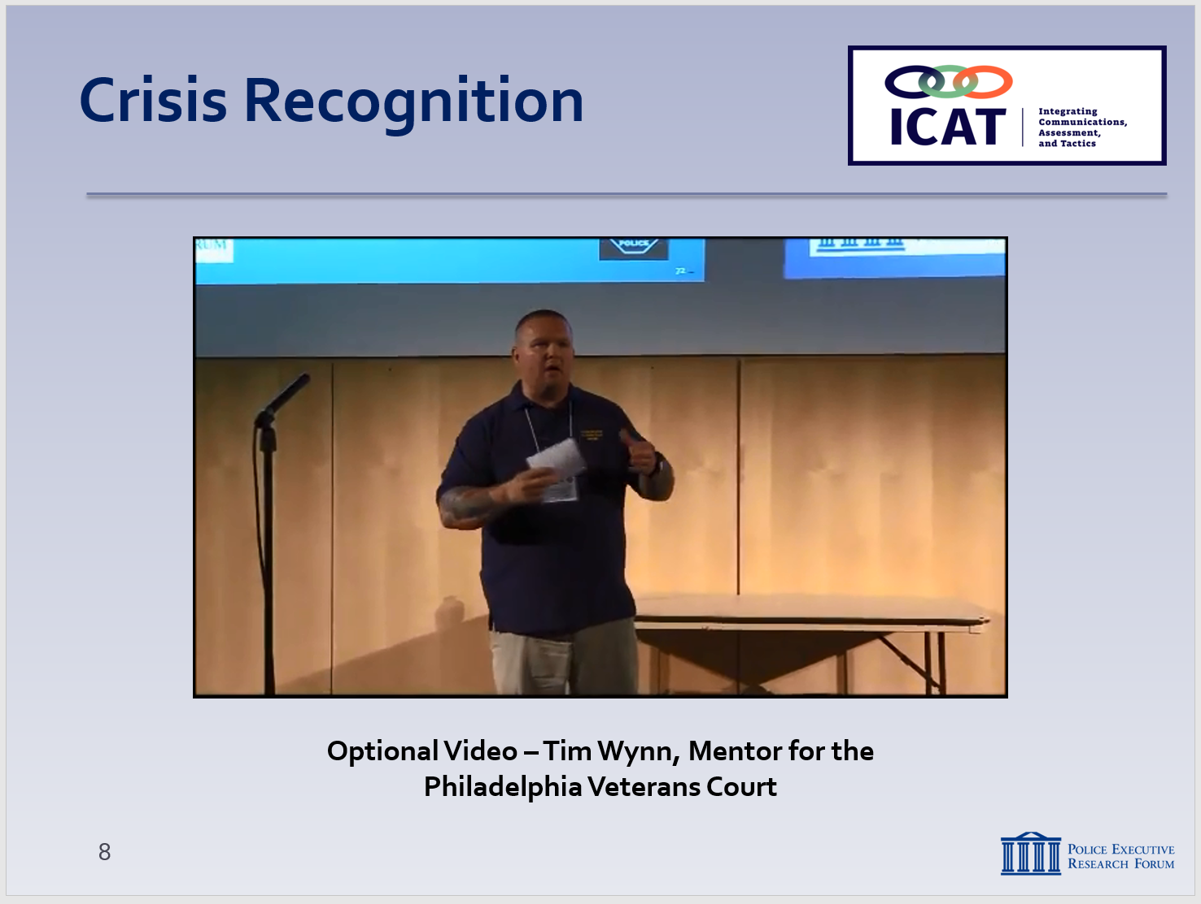

Optional video:
Tim Wynn, who now leads the Philadelphia Veterans Court Mentor program, shares his experiences with post-traumatic stress disorder. This was filmed on July 13, 2017, at an ICAT presentation in Camden County, New Jersey.
https://www.youtube.com/watch?v=ahIEwS0beFI

NOTE: This video is approximately 22 minutes long. Instructors can consider showing all, or only portions, of the video. You may also consider stopping the video at certain intervals and initiating some class discussion, or you can wait until the end for discussion.

SLIDE #9
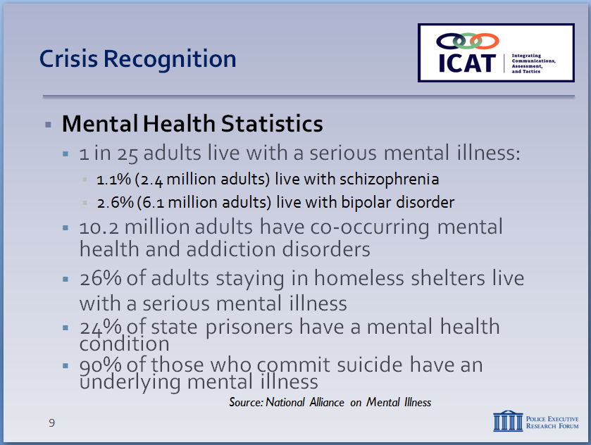

Source and additional facts can be found at: https://www.nami.org/Learn-More/Mental-Health-By-the-Numbers

SLIDE #10
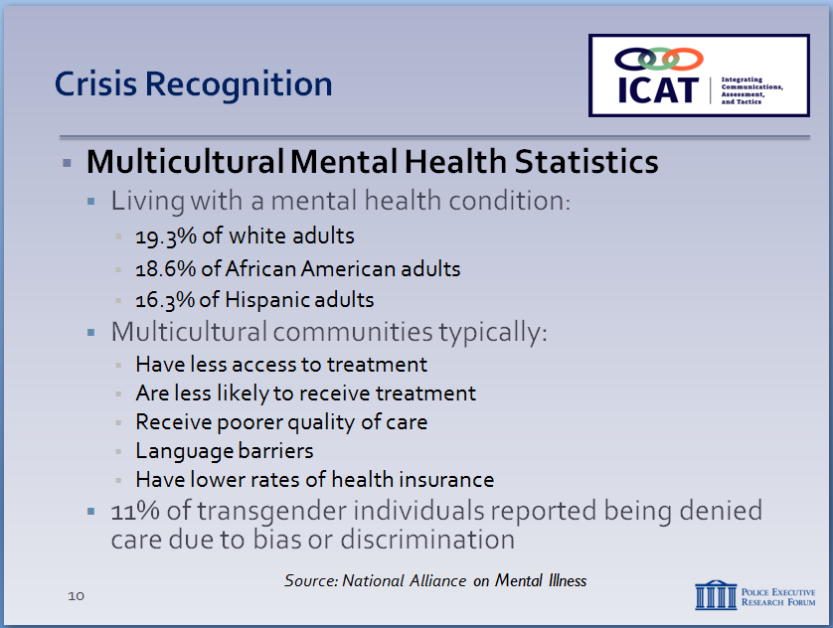

Source and additional facts can be found at: https://www.nami.org/Learn-More/Mental-Health-By-the-Numbers

  - Set up video:
    - Tim Wynn, a veteran who suffers from PTSD following several tours of duty in the Middle East.
    - Upon returning home after his tours of duty, Tim struggled to adjust to life at home.
    - He turned to drugs and alcohol to help cope.
    - This led to several arrests and violent struggles with law enforcement, all the while experiencing the fear and guilt associated with his tours of duty.
    - Tim now works with veterans and other people with mental illness who are in the criminal justice system.
  - Following the video, you can lead a discussion of the key points made in the video:
    - Veterans with combat experience and those with PTSD tend to be hypervigilant. It’s hard for someone returning from a combat tour to shut this off.
      - Be aware that they may be more averse to scenes that may be unsafe or locales that could present a threat to their physical safety.
    - Those suffering from PTSD may meet aggression with aggression.
    - No one’s story is the same, so you may not understand what someone suffering from PTSD is going through.
    - Explaining what is going to happen, rather than forcing them to do it, will always get a more positive response.

- Recognizing Someone in Crisis (continued)
Instructor Notes

SLIDE #9
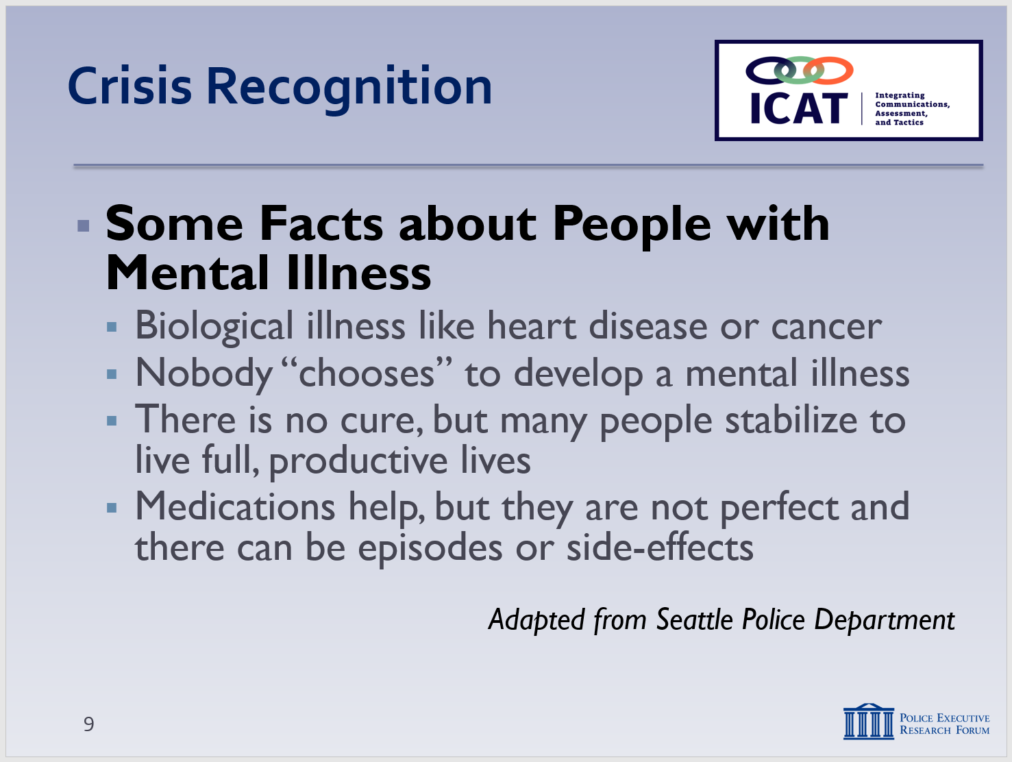

SLIDE #10
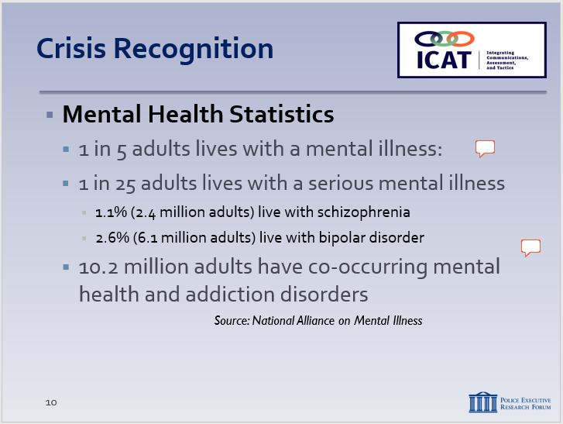

Source and additional facts can be found at: https://www.nami.org/Learn-More/Mental-Health-By-the-Numbers

SLIDE #11

SLIDE #12

Source and additional facts can be found at: https://www.nami.org/Learn-More/Mental-Health-By-the-Numbers

  - Some facts about people with mental illness
    - Mental illness is a biological illness just like heart disease, cancer or diabetes
    - Nobody “chooses” to develop a mental illness – one in four families is affected
    - There is no cure, but many people stabilize to live full, productive lives
    - Medication plus therapy can be effective, but side effects of medication can potentially cause crises and erratic behavior
  - General Mental Health facts
    - 1 in 5 adults lives with mental illness.
      - Nearly 1 in 25 adults lives with a serious mental illness, (approximately 10 million adults)
      - 1.1% (2.4 million adults) live with schizophrenia
      - 2.6% (6.1 million adults) live with bipolar disorder
    - 10.2 million adults have co-occurring mental health and addiction disorders
    - Approximately 26% of adults staying in homeless shelters live with a serious mental illness
    - Approximately 24% of state prisoners have recently experienced a mental health condition
    - 90% of those who commit suicide have an underlying mental illness
  - Multicultural Mental Health facts
    - Mental illness is prevalent in all communities
    - 19.3% of white adults live with a mental health condition
    - 18.6% of African American adults live with a mental health condition
    - 16.3% of Hispanic adults live with a mental health condition
Instructor Notes

SLIDE #13
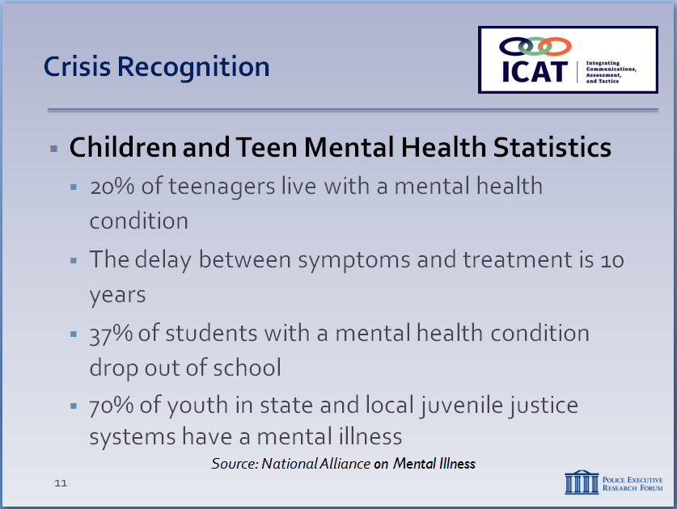

Source and additional facts can be found at: https://www.nami.org/Learn-More/Mental-Health-By-the-Numbers

SLIDE #14
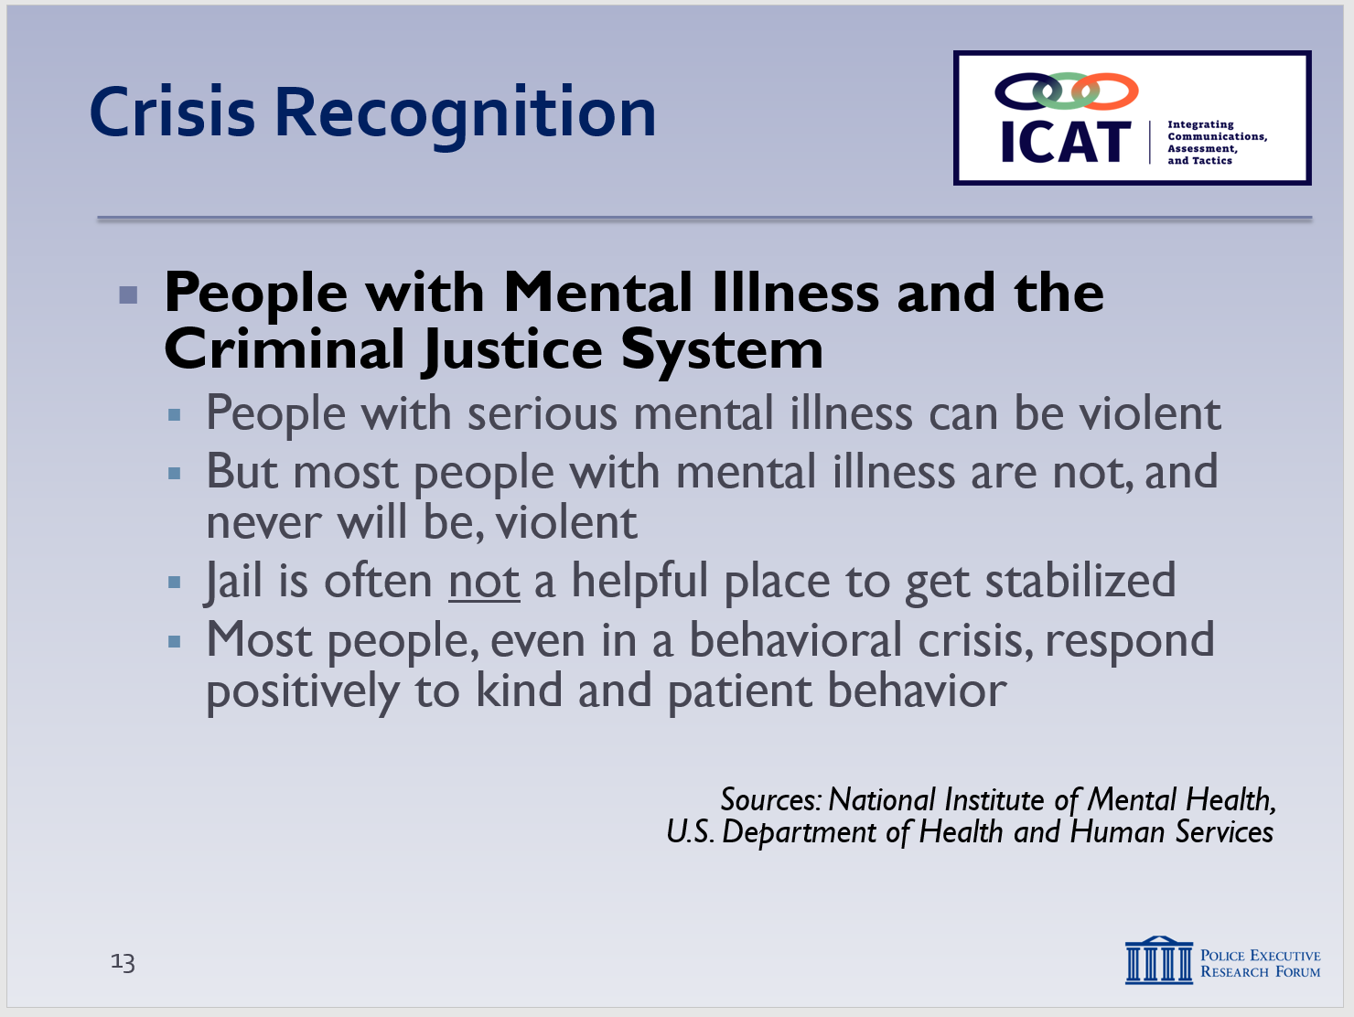

Source: https://www.nimh.nih.gov/about/director/2011/understanding-severe-mental-illness.shtml
Swanson JW. Mental disorder, substance abuse, and community violence: an epidemiological approach. In: Monahan J, Steadman HJ, eds. Violence and mental disorder: developments in risk assessment. Chicago: University of Chicago Press, 1994:101-36.

Source: U.S. Department of Health and Human Services. https://www.mentalhealth.gov/basics/myths-facts/

  - Multicultural communities typically:
    - Have less access to treatment
    - Are less likely to receive treatment
    - Receive poorer quality of care
    - Experience language barriers
    - Have lower rates of health insurance
    - 11% of transgender individuals reported being denied care by mental health clinics due to bias or discrimination
  - Children and Teens
    - 20% of 13-18 year olds live with a mental health condition
    - The average delay between onset of symptoms and intervention is 10 years
    - 37% of students with a mental health condition drop out of school
    - 70% of youth in state and local juvenile justice systems have a mental illness
  - Mental illness and the criminal justice system
    - People with serious mental illness (SMI) can be violent, especially when experiencing a psychotic episode
      - One study: people with SMI are up to three times more likely to be violent than general population
      - When SMI is associated with substance abuse, the risk may increase much further
    - But most people with mental illness are not violent and never will be
      - About 3-5% of violent acts can be attributed to someone with a serious mental illness
      - People with mental illness are 10 times more likely to be victims of violent crime than the general population
Instructor Notes

Police officers are likely to see people when they’re at their worst – in the most serious of crises. Officers are not necessarily seeing a true cross-section of people with mental illness. Encounters with people with serious mental illness can be dangerous. But that doesn’t mean every person with mental illness is violent and dangerous.

SLIDE #15
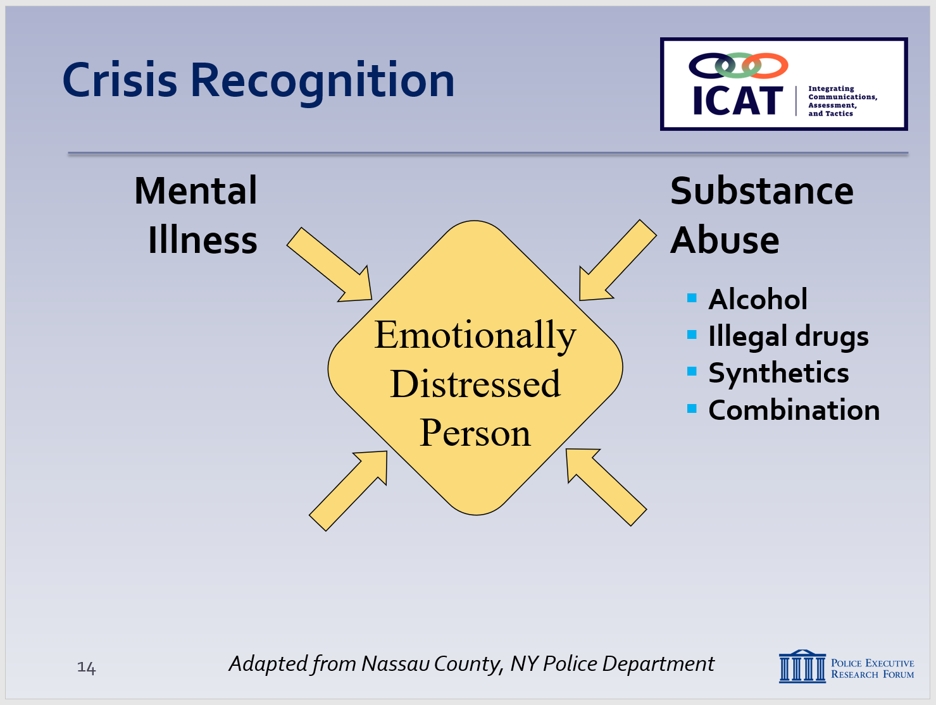

SLIDE #16
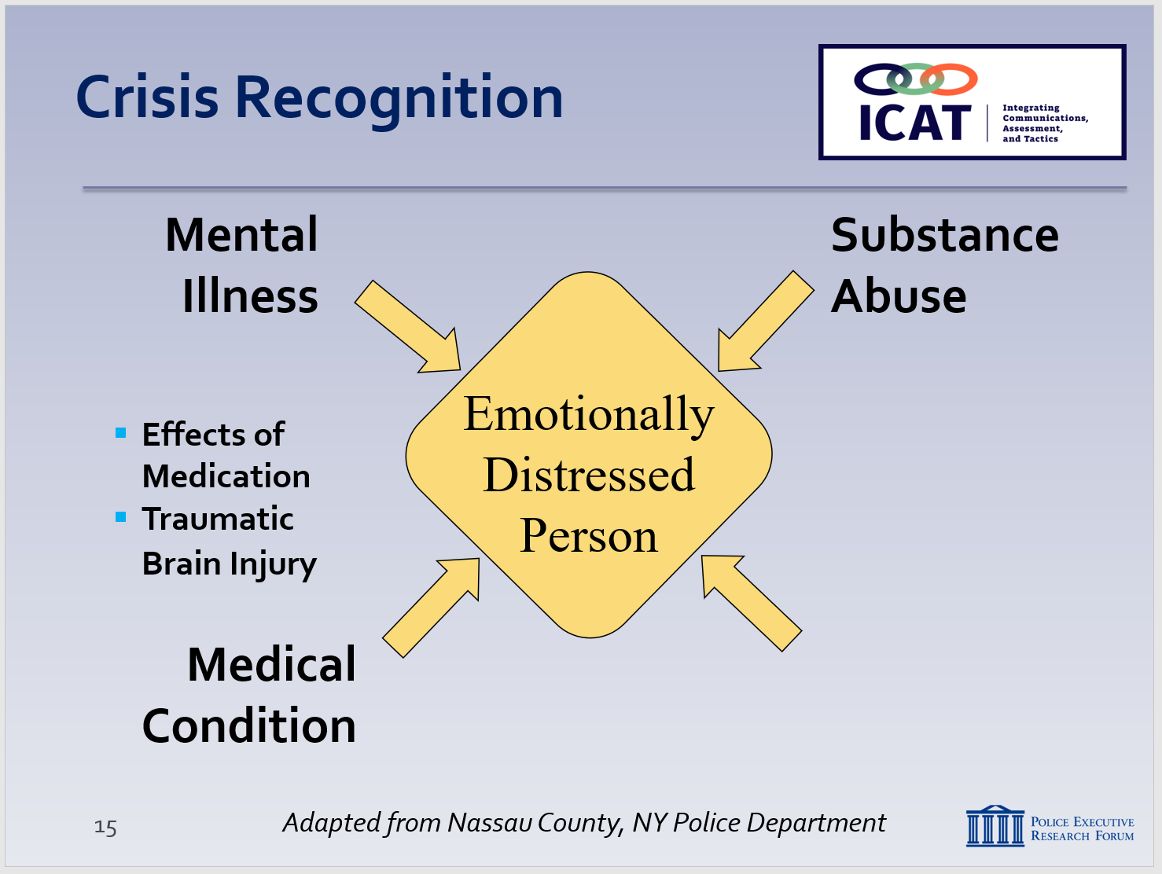
TBI is a serious public health problem—an estimated 2.5 million incidents a year. For more information, http://www.cdc.gov/traumaticbraininjury/get_the_facts.html and http://www.mayoclinic.org/diseases-conditions/traumatic-brain-injury/basics/symptoms/con-20029302

    - Jail is generally not a helpful place for someone to get stabilized
      - Only a small percentage of people with mental illness have committed a crime or qualify for an involuntary evaluation
      - Don’t approach an encounter thinking it will be “solved” if you can get the subject in custody as quickly as possible – a temporary band-aid at best
      - Person will likely be back in the community and you will likely have to respond again

  - Four types of possible contributing factors (Continued)…
    - Substance abuse
      - Alcohol
      - Illegal drugs
      - “Synthetic” drugs
      - Combination of substances
    - Medical condition
      - Including side effects of medication
      - No longer taking medication
      - May turn to substance abuse to “self-medicate”
      - Traumatic brain injuries (TBI)
        - Injury may be obvious (open head wound) or less obvious (closed head wound)
        - Symptoms include being dazed, confused, disoriented; fatigue; dizziness/loss of balance; confusion; agitation/combativeness; unusual behavior; difficulty communicating/ processing information
Instructor Notes

SLIDE #17
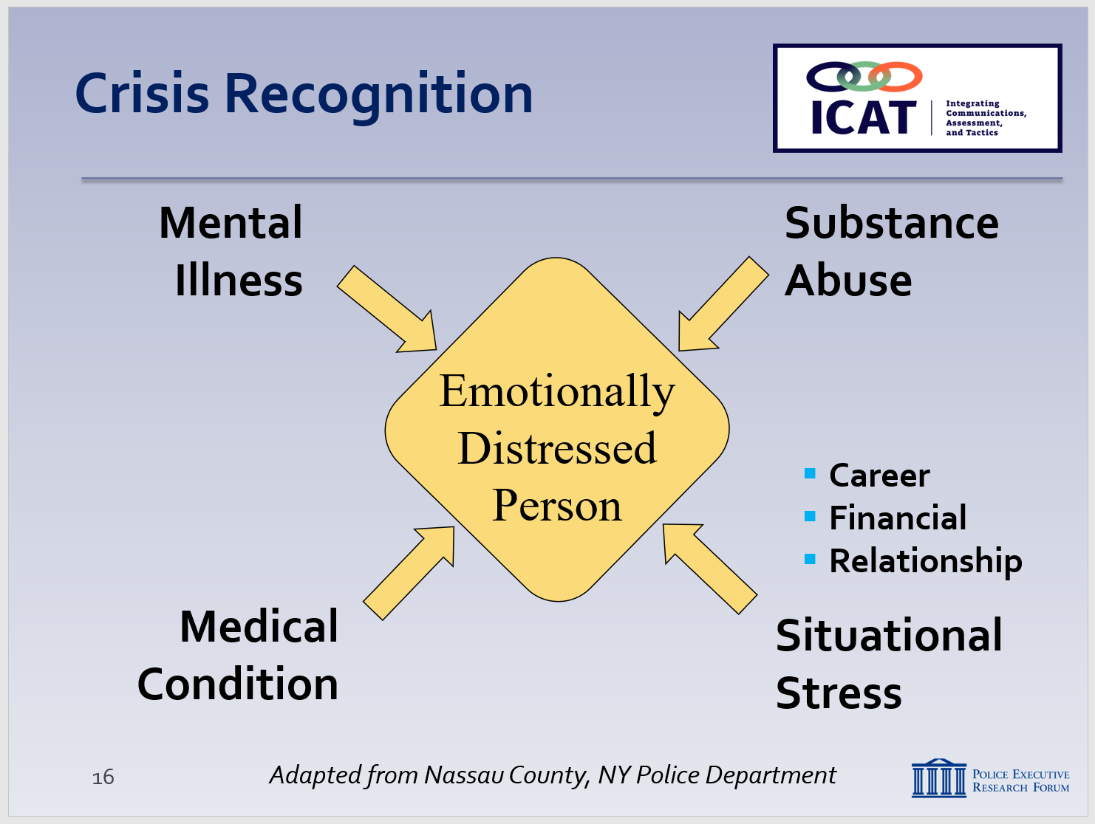

SLIDE #18
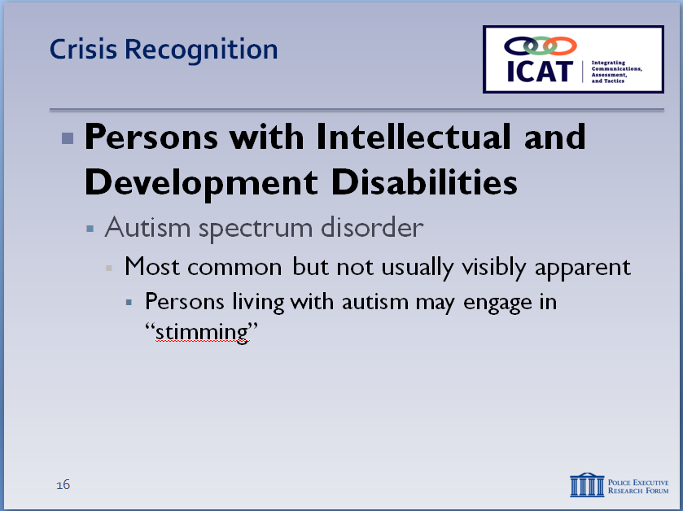

For an overview of intellectual and development disabilities, https://www.nichd.nih.gov/health/topics/idds/Pages/default.aspx

Source: https://www.nimh.nih.gov/health/topics/autism-spectrum-disorders-asd/index.shtml

        - Creates big challenges for police officers
    - Situational stress
      - Job loss
      - Financial troubles
      - Relationships
      - Given the nature of our jobs and the regular stressors in our lives, how many times have we experienced situational stress, causing our emotions to run high and our rational thinking to drop? An excess of this, especially when mixed with substance abuse can lead to emotional distress.
    - Or it can be a combination of these factors – this can especially challenging for the police

  - Important to remember that not everyone behaving erratically is suffering from emotional distress – there are other factors that officers need to consider …
    - Intellectual and developmental disabilities
      - Disorders usually present in birth that negatively impact a person’s physical, intellectual and/or emotional development into adulthood, and require support
      - Common examples:
        - Autism spectrum disorder
          - This is the most common, and is often not visibly apparent.
          - Symptoms can include:
      - Difficulty communicating and interacting with others which can hurt the individual’s ability to function socially, at school or work, or other areas of life.
      - Communicating effectively with the police and other authority figures can also be diminished
Instructor Notes

For more information on Autism please visit: http://nationalautismassociation.org/resources/autism-fact-sheet/

SLIDE #19
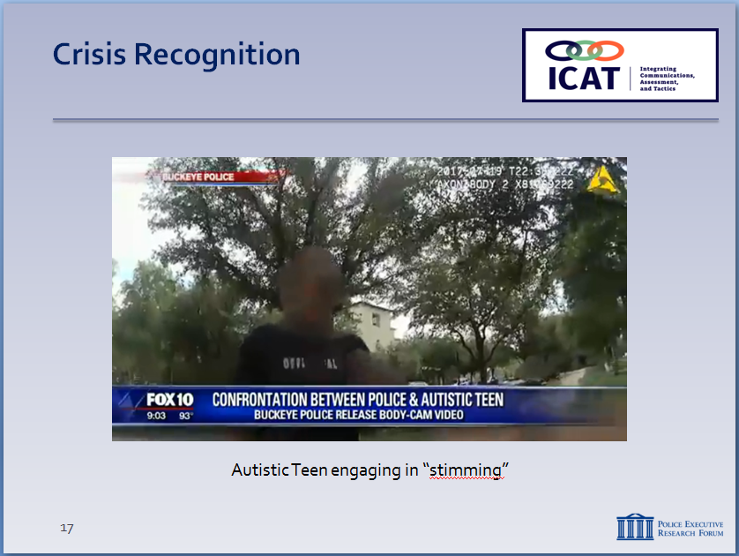

For more information on stimming, please consult: https://www.autism.com/symptoms_self-stim

      - May include “stimming”
        - Behavior common in autism where a subject moves their body in a repetitive motion or repetitively moves objects to stimulate their senses.
        - These actions can include, staring at lights, repetitive blinking, snapping fingers, rubbing skin with hands or other object, rocking back and forth or side-to-side, inserting objects into one’s mouth, or sniffing.
      - In this video from Buckeye, Arizona, a police officer stops a young teen he suspects of using drugs. The teen is autistic, is engaging in stimming behavior and is outside, waiting for his caretaker.
        - Show Video
        - Cerebral palsy
          - Symptoms can include:
Instructor Notes

SLIDE #20
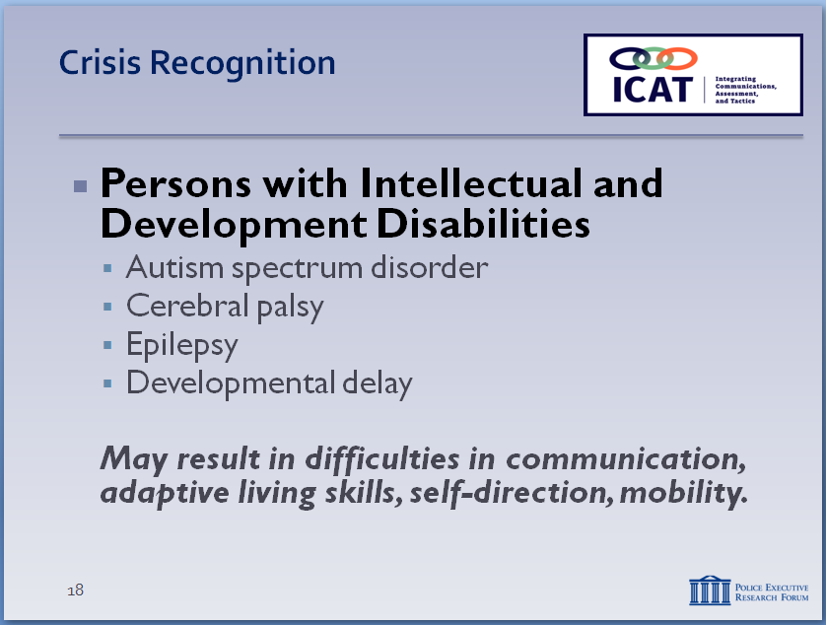

Cerebral Palsy Source: https://www.ninds.nih.gov/Disorders/Patient-Caregiver-Education/Hope-Through-Research/Cerebral-Palsy-Hope-Through-Research

Epilepsy Source: https://www.epilepsy.com/learn/about-epilepsy-basics/what-epilepsy

SLIDE #21
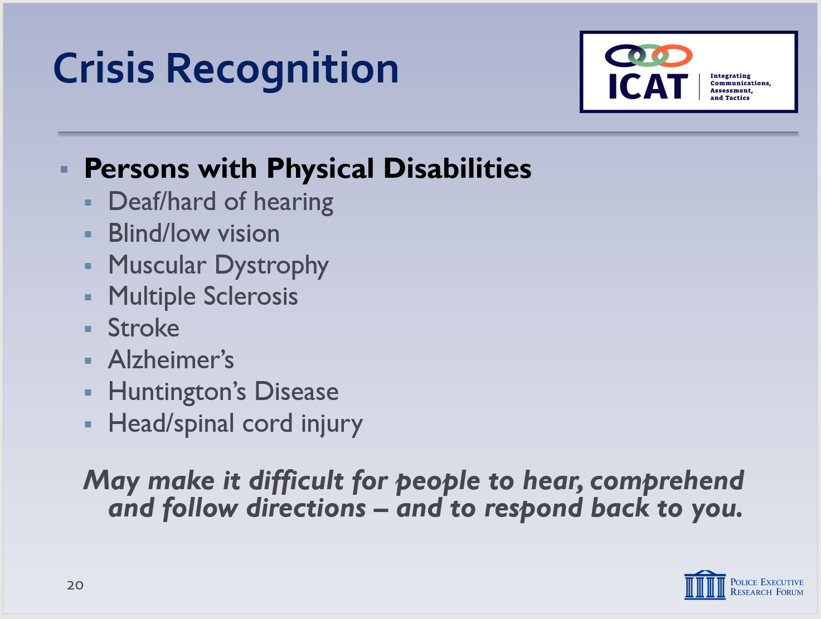

For general information on physical disabilities, http://hwa.org.sg/news/general-information-on-physical-disabilities/

            - Lack of muscle coordination
            - Random involuntary movements
            - Poor motor skills
            - Difficulty swallowing or speaking
        - Epilepsy
          - Characterized by unpredictable seizures
        - Developmental delay
      - May result in difficulties in life areas, such as communication, ability to learn, adaptive living skills, self-direction, self-help, and/or mobility
      - Common police calls (often no crime involved):
        - Walking into traffic
        - Entering homes/looking into windows
        - Wandering
        - Rearranging store displays
        - Following customers around a store
      - May be attracted to shiny objects, overly sensitive to light, sound or touch
      - May run from the police or display erratic behavior because of fear, not necessarily because they committed a crime
    - Physical disabilities
      - A disabling condition or other health impairment that requires adaptation
      - Can be congenital, acquired with age, or the result of an accident
      - Some common examples:
        - Deaf/hard of hearing
        - Blind/low vision
        - Muscular Dystrophy
        - Multiple Sclerosis
        - Stroke
        - Alzheimer’s
        - Huntington’s Disease
        - Traumatic neurological disorders
      - Physical disability may make it difficult for a person to hear, understand and follow directions
      - Communications may not work – not because the person is defiant or non-compliant, but because they can’t hear or comprehend, and can’t respond back to you
    - Persons with physical and/or developmental disabilities may exhibit some of the same unusual or erratic behaviors as EDPs
      - Don’t assume someone behaving erratically suffers from mental illness
      - It could be one of many factors – or a combination of factors
Instructor Notes

SLIDE #22
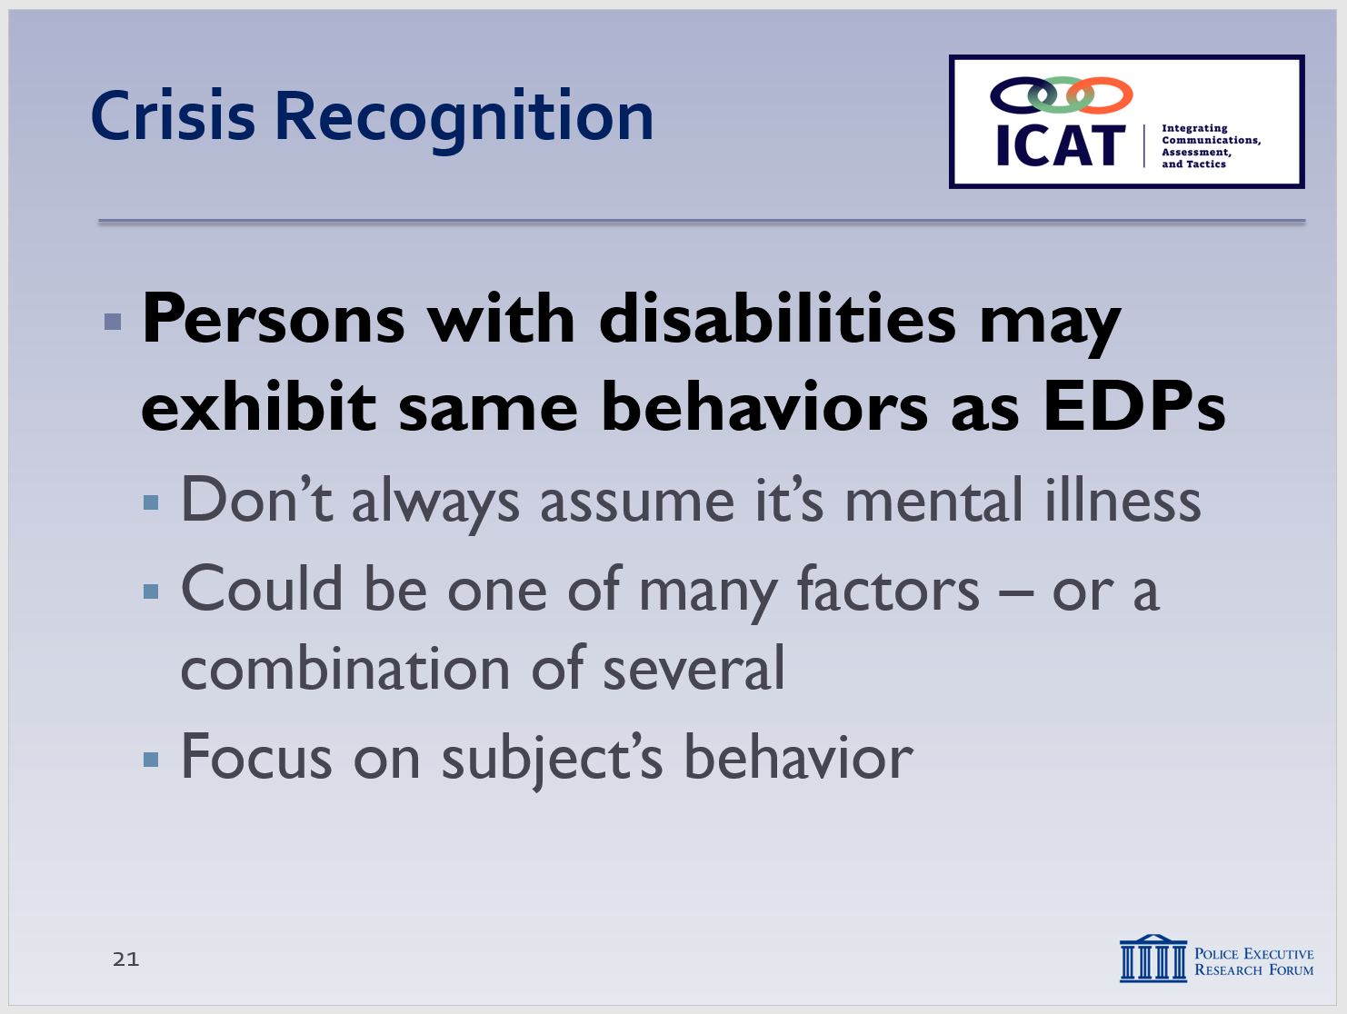

SLIDE #23
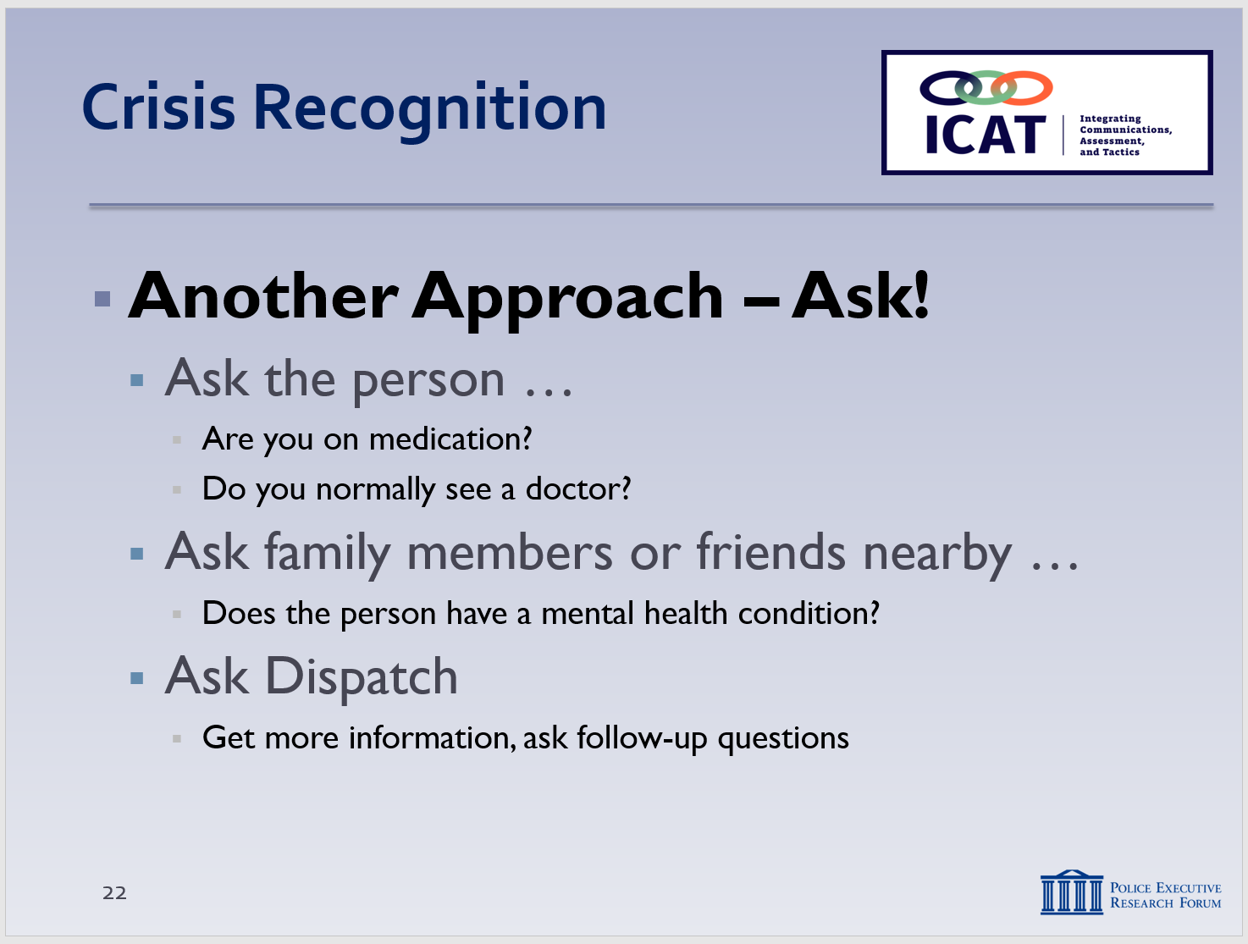

  - Focus on the subject’s behavior, which can provide important clues. Is he or she …
    - Responding to dialogue/verbal commands?
    - Coherent? (Or talking in “word salad?”)
    - Able to make eye contact?
    - Agitated? (Shouting, pacing, talking to people not there)
    - Talking to themselves?
    - What is the state of their hygiene and clothing
    - Environmental factors (e.g., overflowing trash, aluminum foil on windows, etc.)
  - One other effective (but often underutilized) approach to recognizing someone in crisis – Ask!
    - If the situation lends itself, ask the person questions such as …
Instructor Notes

SLIDE #24
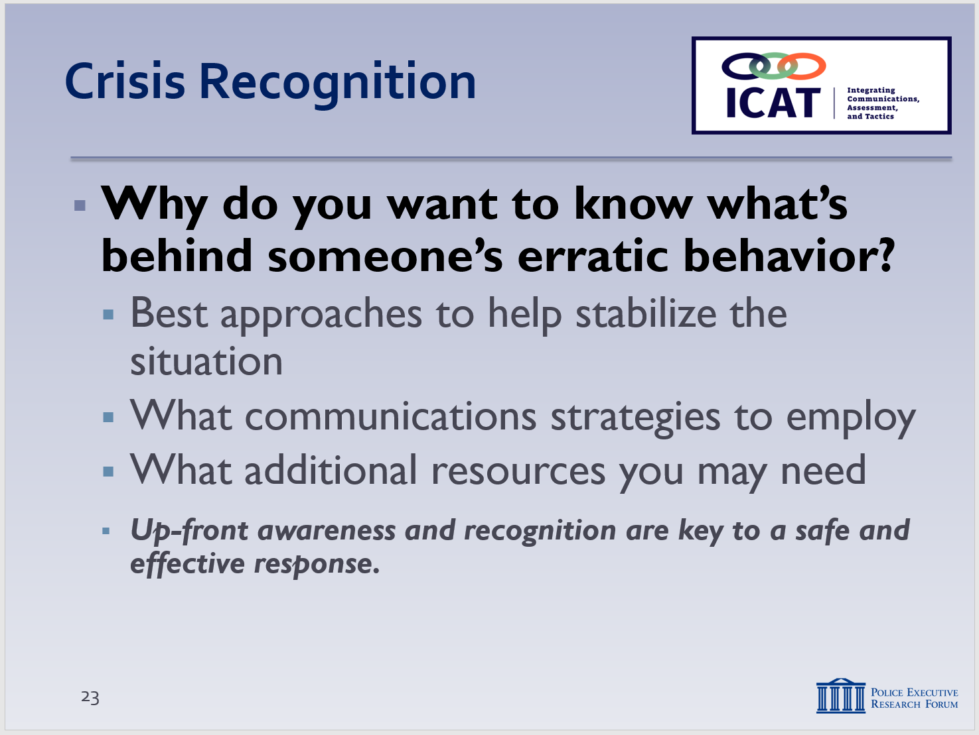

Crisis recognition is part of Step #1 in the Critical Decision-Making Model: Collect Information.

As with CIT training, officers are not expected to become expert clinicians. Rather, we are trying to understand mental health issues and indicators for the purpose of having an effective response/communication strategy.

SLIDE #25
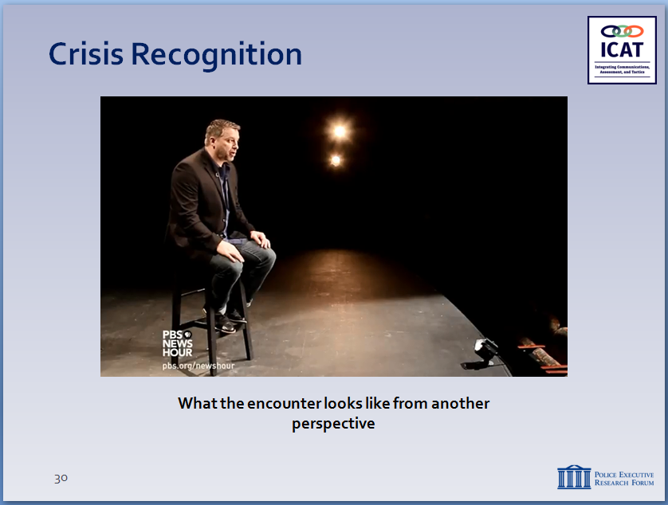

For video, transcript and comments, go to: https://www.youtube.com/watch?v=texgQ_ZtsLw

For background on Paton Blough and Rehinge, http://rehinge.com/

      - Are you on medication?
      - Do you have a doctor you normally see?
      - How can I help with what’s bothering you?
    - Ask family members or friends nearby …
      - Does the person have a mental health condition?
      - A physical or development disability?
      - What might the person respond to positively?
    - Ask the Dispatcher to get more information from the caller or previous call history
  - Why do you want to take the time to try and understand what’s behind someone’s erratic behavior? Because that information can help you figure out …
    - What approaches might work to help stabilize the situation
    - What communication strategies to employ
    - What additional resources you may need to resolve the situation
    - Up-front awareness and recognition are key to coming up with a safe and effective response

We’ve mostly discussed these encounters from the perspective of the responding police officer. But what do they look like from the perspective of someone experiencing a behavioral crisis?
- Let’s watch a video, then discuss.

- Learning Activity – Paton Blough Video
  - What the encounter looks like from the other perspective
  - Set up video
    - Paton Blough suffers from Type 1 Bipolar disorder, which he didn’t discover until age 26
    - For years, he experienced manic episodes that led to various encounters with the police (6 arrests)
    - Now in recovery, he speaks about those incidents
    - This is a 2016 video essay he did for PBS
  - Play Paton Blough video
    - Discuss briefly – possible comments to explore:
      - “Rules of society don’t apply to me when I’m having one of my episodes.”
      - “You can imagine the kind of reaction someone like me might have when delusions trigger an incident in which a police officer wants to engage with me or, worse, arrest me.”
      - “The other three (arrests) were extremely violent, because, in my head, I was fighting for my life.”
      - “One time, I was arrested by an officer who I believed naturally possessed many of the things we train. He slowed down and didn’t force the issue.”
Instructor Notes

SLIDE #26
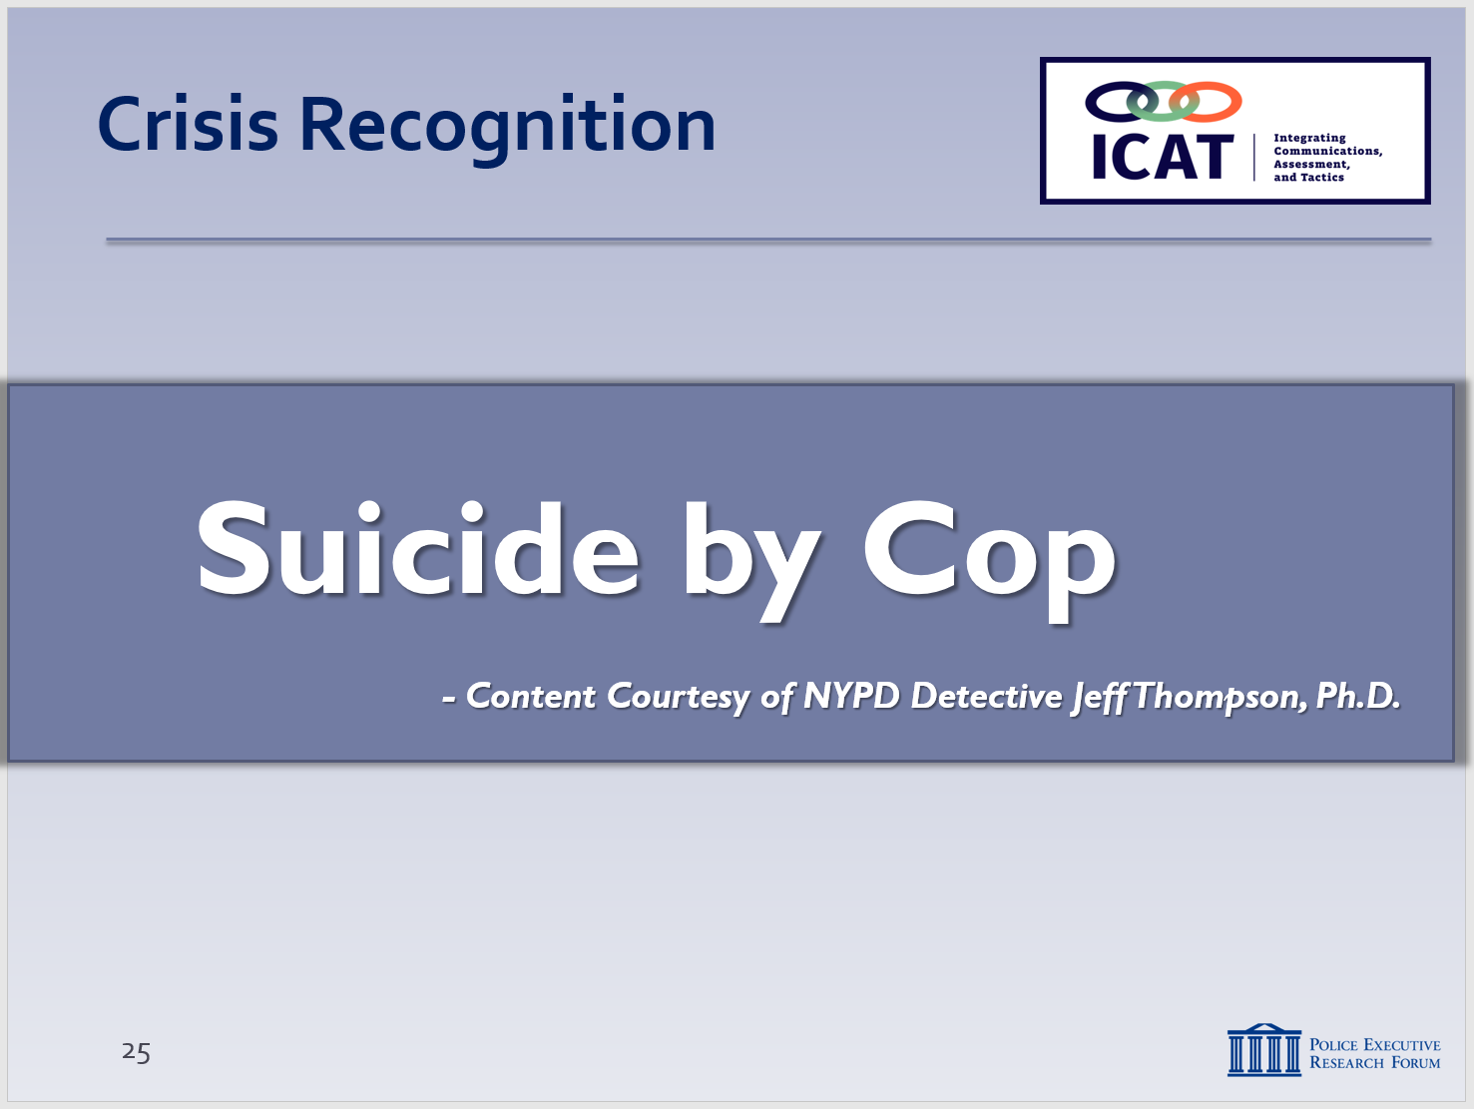

SLIDE #27
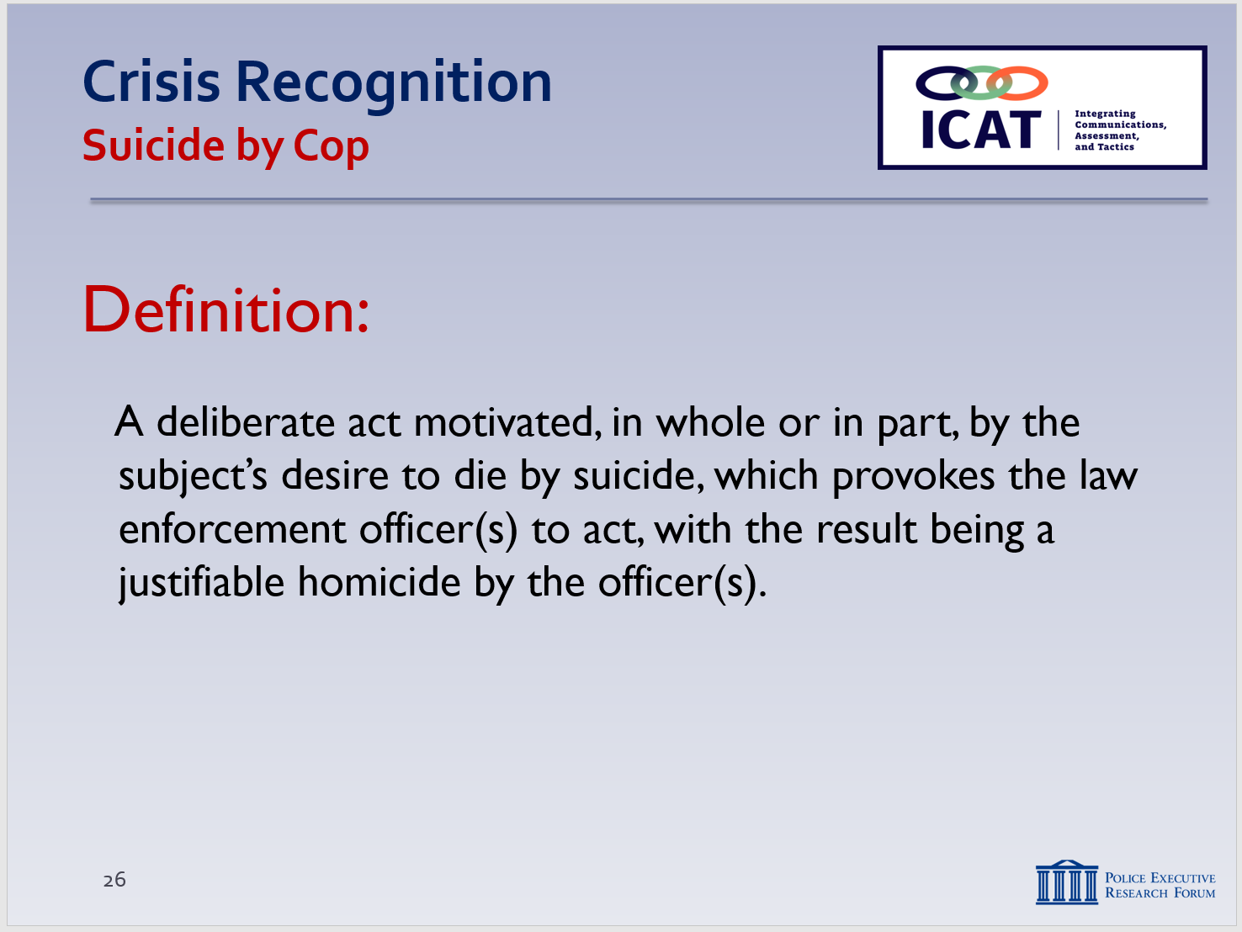
From NYPD Detective Jeff Thompson, Ph.D.

      - “Make the person feel they’re in control – slow down and stay calm.”

- Suicide-by-Cop Incidents
Note: This section is courtesy of NYPD Detective Jeff Thompson, Ph.D.

  - Definition of a Suicide-by-Cop incident:
    - A deliberate act motivated by the subject’s desire to die by suicide, which provokes law enforcement to act, with the result being a justifiable homicide by law enforcement.

  - There are three criteria that suicide-by-cop scenarios usually meet:
Instructor Notes

SLIDE #28
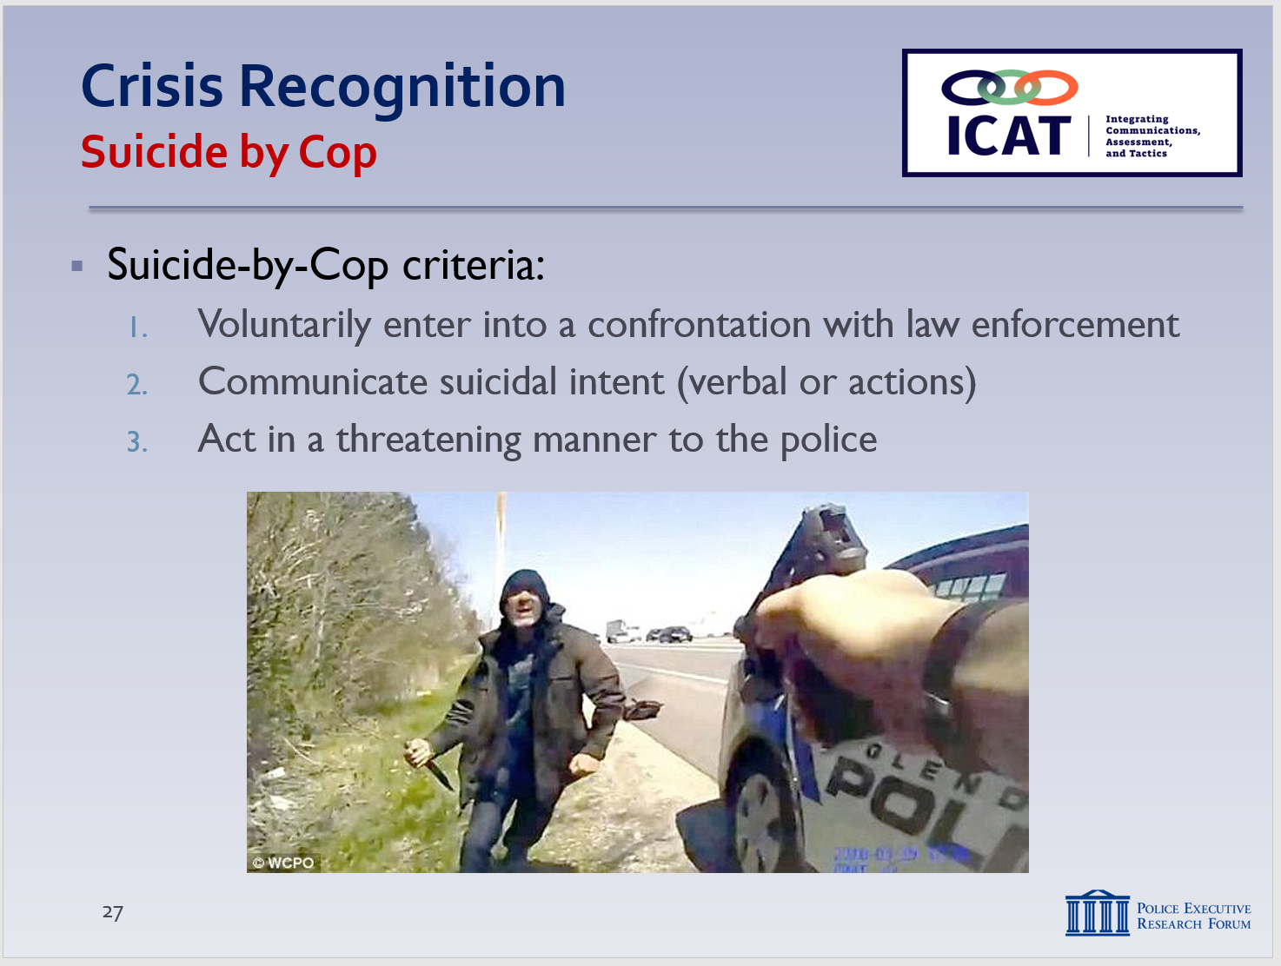

SLIDE #29
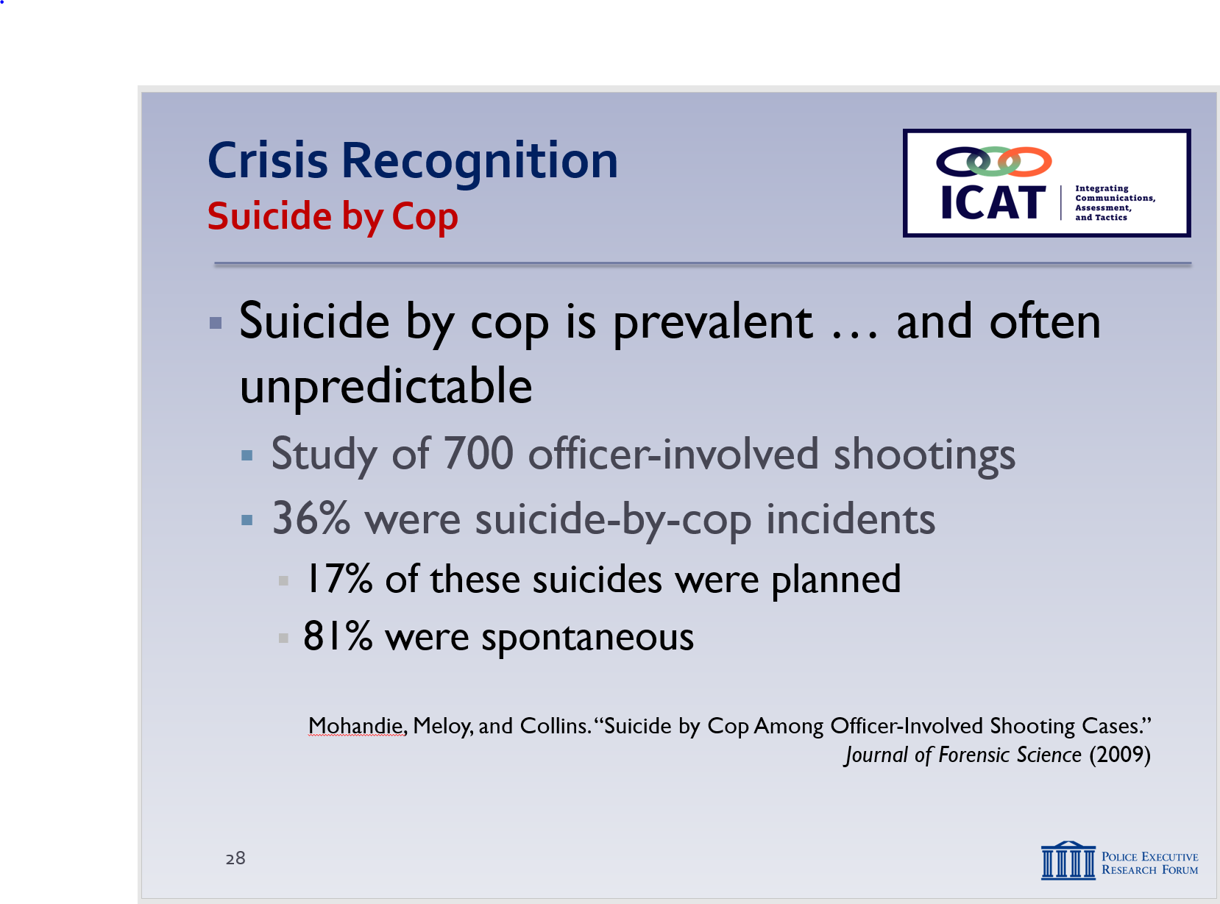

SLIDE #30
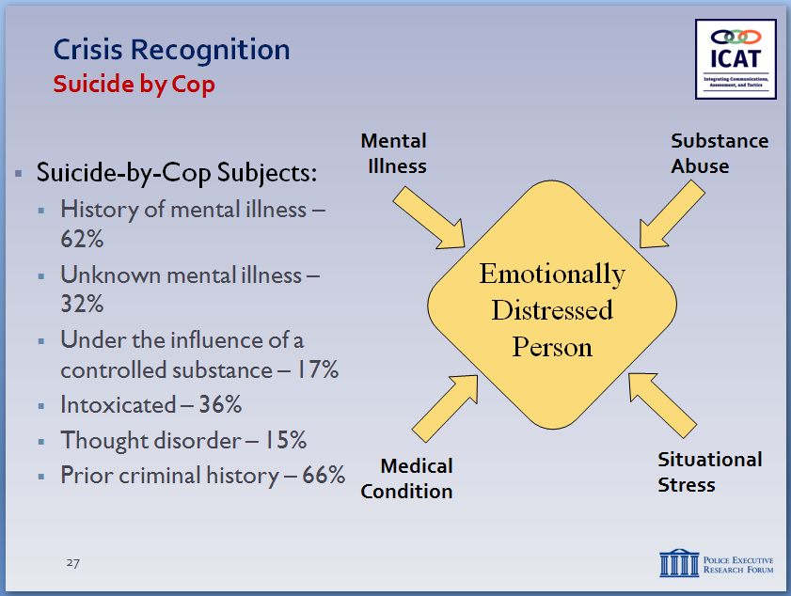
Suicide by Cop statistics come from:
Mohandie, Meloy, and Collins. “Suicide by Cop Among Officer-Involved Shooting Cases.” Journal of Forensic Science (2009
Link to study: https://www.valorforblue.org/Documents/Publications/Public/Suicide_by_Cop_Among_Officer-Involved_Shooting_Cases.pdf

Additional information:
http://www.slate.com/articles/news_and_politics/politics/2014/08/suicide_by_cop_the_dangerous_term_that_stops_us_from_asking_hard_questions.html

    - The subject voluntarily enters into a confrontation with law enforcement
    - The subject will communicate suicidal intent, either verbally or through their actions
    - The subject will act in a threatening manner, attempting to force law enforcement to act

  - Statistics:
    - A 2009 study in the Journal of Forensic Science examined 700 officer-involved shootings.
      - Of those shootings, 36% were classified as suicides-by-cop
      - 17% of those suicides were planned
      - 81% were spontaneous
        - In those spontaneous instances, subjects became suicidal in response to their immediate circumstances or police intervention
    - Many suicide-by-cop subjects have a history of mental illness and substance abuse:
      - 62% of subjects had a history of mental illness
      - 32% had an unknown history of mental illness
      - 17% of subjects were under the influence of a controlled substance
      - 36% of subjects were under the influence of alcohol
      - The average BAC was 0.16
      - 15% of subjects had a “Thought Disorder,” and
      - 66% of subjects had a prior criminal history

    - The subject can experience a wide range of emotions and characteristics including:
Instructor Notes

SLIDE #31
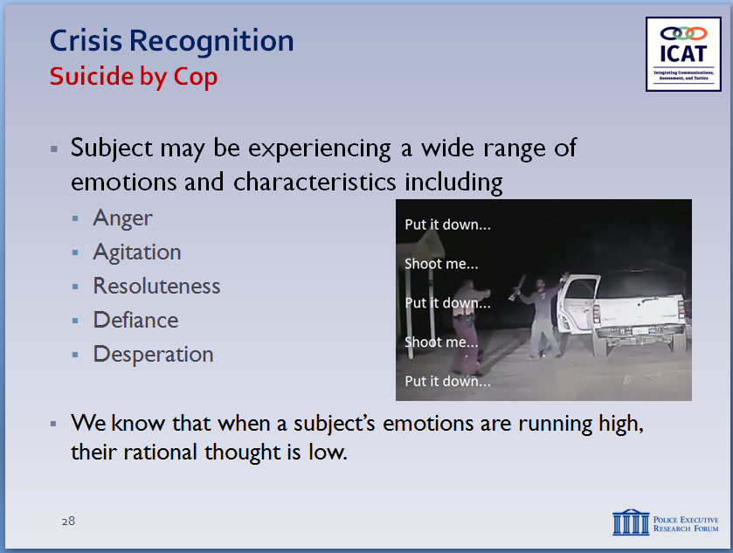

SLIDE #32
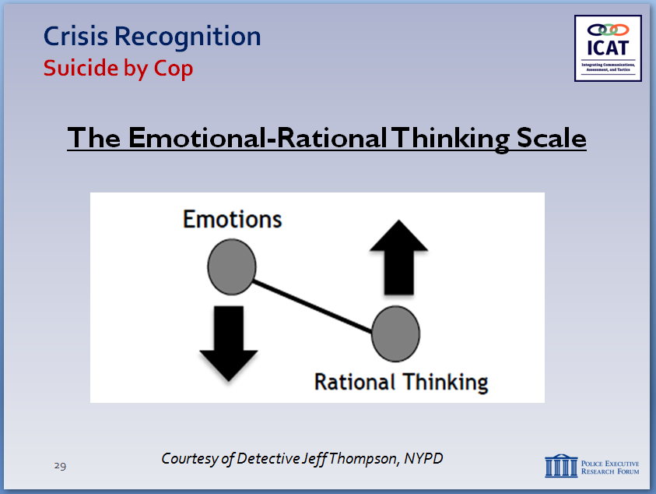

SLIDE #33
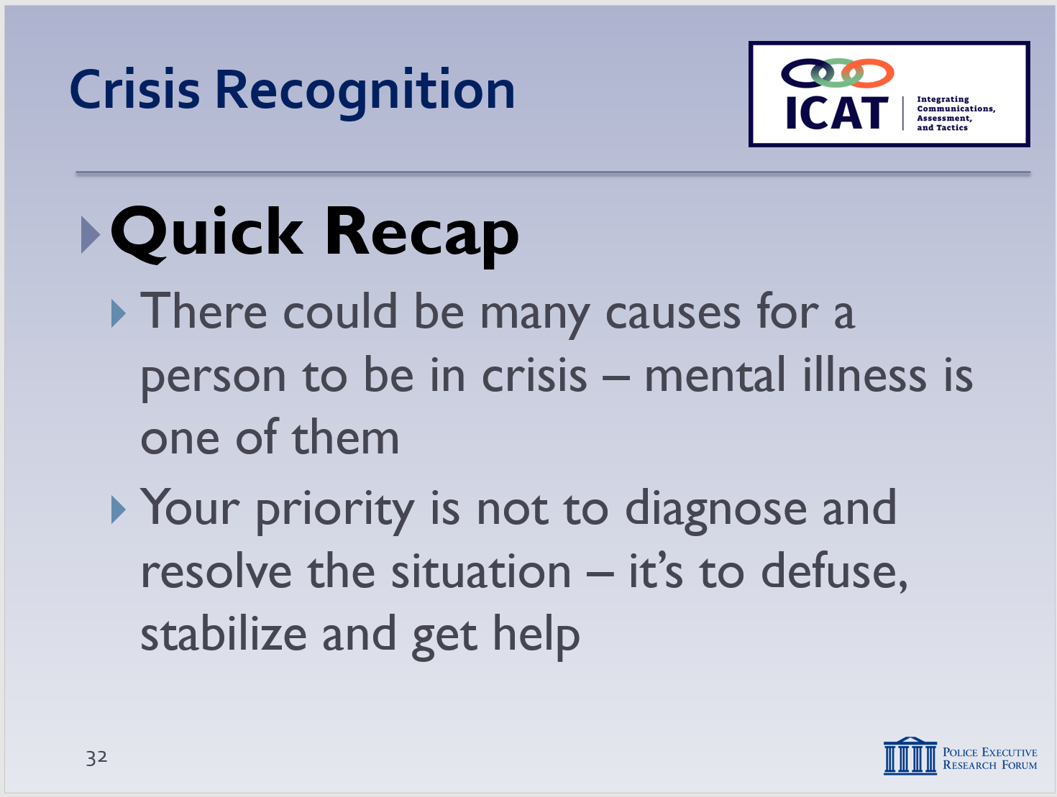

      - Anger
      - Agitation
      - Resoluteness
      - Defiance
      - Desperation

    - Their emotions are running high. When emotions run high, rational thought is low. This idea is appropriately illustrated by the Emotional-Rational Thinking Scale.
- This principle applies not just to suicide-by-cop encounters but to a wide range of police encounters with persons in crisis.
- We’ll see this illustration again, later during the training. Given all of this, it’s vital to pay attention to how we respond to someone in crisis, both in how we communicate with someone and how we tactically approach a situation.
- We’ll cover those aspects in the next two modules.

- Recap and Discussion
  - Quick recap
    - Many reasons for a person to be in crisis (or a combination of reasons)
      - Mental illness is one of them (but not the only one)
      - Officers need to be on the lookout for a number of reasons a person may be behaving erratically
    - Your priority is not to diagnose the person and try to resolve the situation immediately
      - Priority is to defuse, stabilize and get additional resources who can help you to the scene
    - Emotional-rational thinking scale
      - As emotions rise, rational thinking declines
      - Lowering someone’s emotions can help them think more rationally and make better decisions
      - Won’t always be possible, but almost always worth a try
    - How?
      - Through empathy, communication, showing respect, slowing things down, trying to make a connection
      - All about trying to get voluntary compliance, so the use of force becomes less likely or unnecessary
Instructor Notes

SLIDE #34
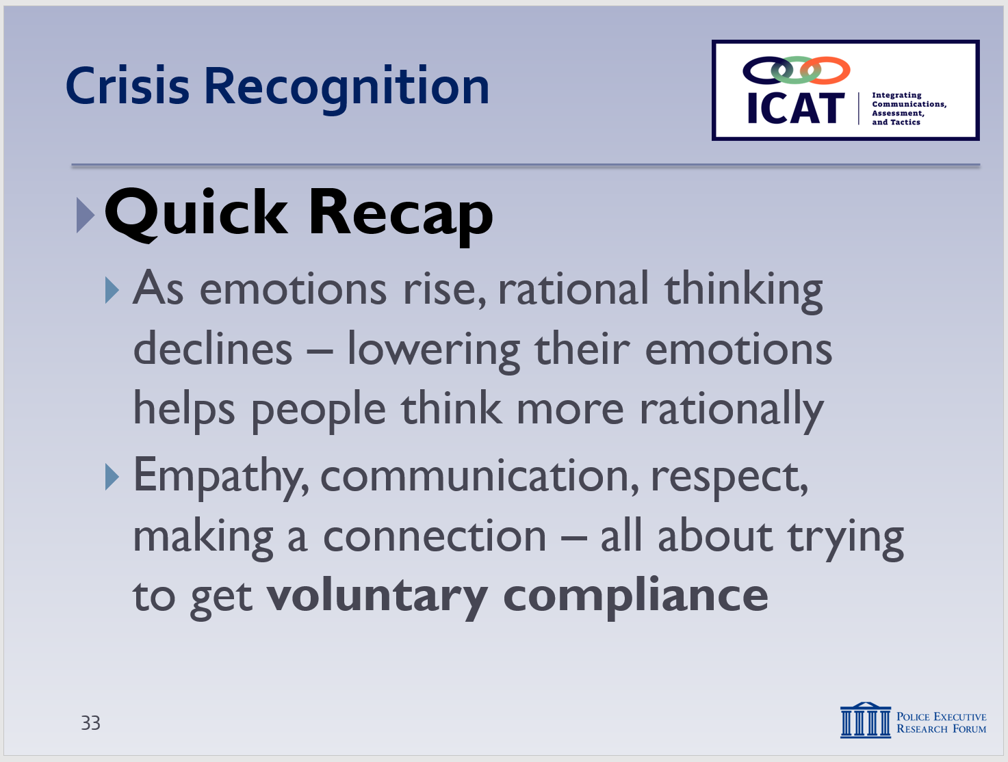

SLIDE #35
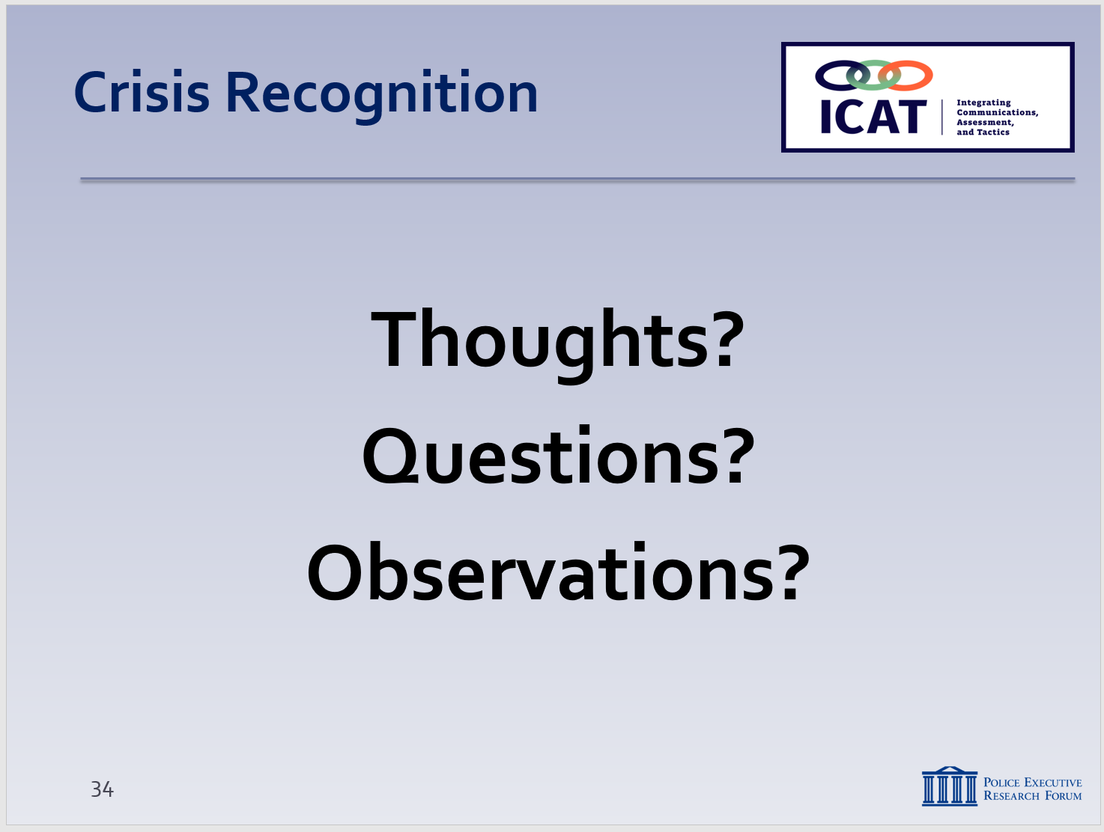

  - Any thoughts, questions, observations?
    - Review any agency-specific policy considerations not previously discussed (as appropriate)
    - Distribute class evaluations of the module (if appropriate)

- Learning Activity – (Community Mental Health Engagement) – Optional
Activity: Group Engagement Exercise
Activity Time: 60 minutes
Activity Learning Objective: To directly expose students to the real-life experiences, concerns and hopes of individuals living with a mental illness through a structured presentation and question-and-answer session with a person with mental health issues
Required Equipment: Easel pads, markers; digital presentation (as needed)
Facilitator Instruction: There are a number of options for organizing this group exercise:
- NAMI “In Our Own Voice” program. The National Alliance on Mental Illness offers a free program in which local NAMI affiliates arrange for people with mental health conditions to share their personal stories. You can schedule a presentation through a local NAMI affiliate. For more information, go to https://www.nami.org/Find-Support/NAMI-Programs/NAMI-In-Our-Own-Voice.
- Local mental health department. Contact the mental health agency in your community to see if it has, or can arrange, a presentation.
- Local mental health provider community. Similarly, contact a local provider of mental health services to see if it has, or can arrange, a presentation.
Whichever approach is selected, the setting for this activity should be comfortable and conversational. The presenter should be given sufficient time to make a presentation, and there should be ample time for questions and answers. If needed, the Facilitator may need help start the Q&A. Ask appropriate questions about such things as the individual’s past experience (good and bad) with the police, how he or she feels when approached by an officer, how he or she might react to police directions or commands, and how the police can most effectively communicate and interact with you. Try to ensure that the discussion stays focused on the individual’s interactions with the police.

